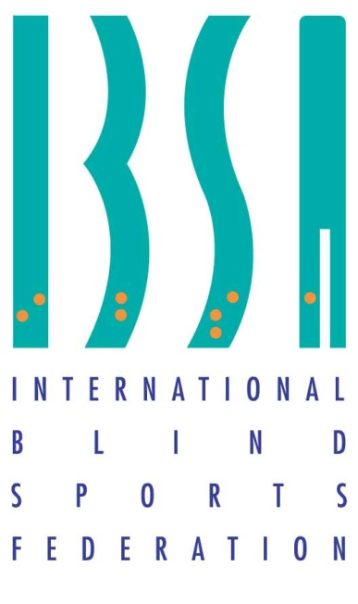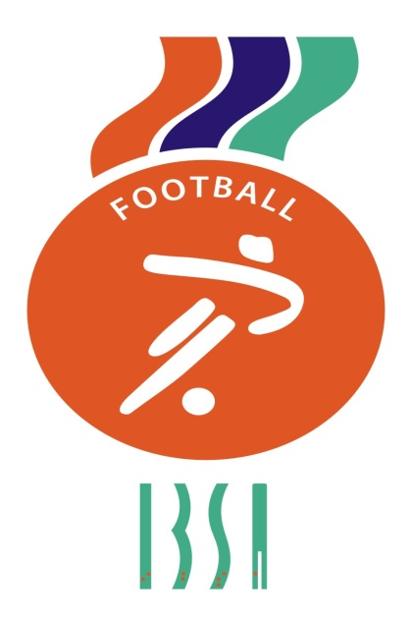

INTERNATIONAL BLIND
SPORTS FEDERATION
FOOTBALL FIVE-A-SIDE LAWS
2017-2021

B1
CATEGORY

IBSA (International Blind Sports Federation) Football Subcommittee

PRESIDENT
Ulrich Pfisterer (Germany)
Email: football.chair@ibsasport.org
MEMBERS

Toussaint Akpweh (Special Advisor Development /Africa Representative – France)

Jeff Davies (Inclusion – United Kingdom)

Domingo Latela (Legal adviser/Americas representative - Argentina)

Jonathan Pugh (Coaching Advisor – United Kingdom)

Sunil Mathew (IT & Communications - Asia – India)

Eigo Matzusaki (Marketing / Fundraising / Asia Representative – Japan)

Dave Connolly (Emerging Countries Oceania Representative – Australia)

Gaël Riviere (Athletes´ Representative)

Helder Maciel Araujo

REFEREEING CO-ORDINATOR

Mariano Travaglino (Argentina)
football.referees@ibsasport.org

Should there be any discrepancy in the interpretation of the blind football rules, the English version shall prevail.

Modifications to the previous rules of the game are marked with the following symbol (asterisk): *

CONTENTS
B1 CATEGORY – LAWS OF THE GAME Page
1 The Pitch 5
2 The Ball 9
3 Number of Players 10
4 Players’ Equipment 13
5 Referee 15
6 The Assistant Referees 16
7 Timekeeper, Scorer, and PA Speaker 17
8 Duration of the Match 19
9 Start and Restart of Play 20
10 Ball in and out of Play 22
11 Method of Scoring 23
12 Fouls and Misconduct 24
13 Free Kicks 28
14 Accumulated Fouls 30
15 Penalty Kick 32
16 Kick-In 34
17 Goal Clearance 35
18 Corner Kick 36
Procedures to determine the winner of a match 37
Competition Regulations 38
Eyeshades – overview 40
FAQs and IBSA responses 42
Sanctions at a tournament series 47
1 THE PITCH
The pitch shall conform to the dimensions and appurtenances set out in the following diagram:

Diagram
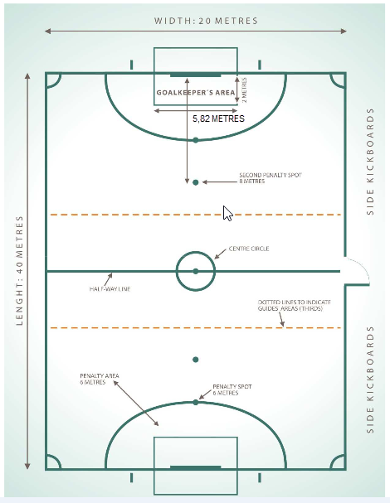

The pitch shall always be uncovered to allow for optimum acoustics.

To ensure competition, alternative facilities must be available, with a covered playing surface of similar characteristics, in case of adverse weather conditions beyond the control of the Organising Committee - persistent rain, strong winds, etc. This playing surface may also have a wooden, synthetic rubber or similar surface.

The alternative facilities must be inspected and approved by the IBSA Technical Delegate and the Organising Committee prior to the start of competition.

The IBSA Technical Delegate and the Organising Committee shall ensure that the floodlighting of the pitch is suitable for games played at night or indoor if needed.

DIMENSIONS:
The pitch must be rectangular. The length of the touch line must be greater than the length of the goal line.

INTERNATIONAL MATCHES

LENGTH 40 metres
WIDTH 20 metres

PITCH MARKINGS
The pitch is marked with lines, which belong to the areas of which they are boundaries.
The two longer boundary lines are called touch lines. These touchlines shall be formed with kickboards that cover the entire length of the touch lines and extend one metre beyond both goal lines on both sides of the pitch. The kickboards shall be between one metre and one metre twenty centimetres high and could be angled at no more than 10 degrees away from the pitch.

The two shorter lines are called goal lines.

All lines are 8 centimetres wide. The pitch is divided into two halves by the halfway line.

The centre mark is indicated at the midpoint of the halfway line. A circle with a radius of 5 metres is marked around it. *

MARKING THE GUIDES’ AREAS
The guides’ areas (thirds) shall be marked in the following way:

At a distance of 12 metres from the goal lines a dotted line shall be marked parallel to the goal lines from one side of the pitch to the other. The pitch shall therefore be divided in three thirds which shall be known as:

1 Defensive third;
2 Midfield third;
3 Attacking third

THE PENALTY AREA *
A first point mark at a distance of one meter and fifty-eight shall be measured from the midpoint of the goal line towards the right kickboard. An imaginary line of 6m in length is drawn from the first point mark and at right angle to the goal line; at the end of this line a quarter
circle is drawn in the direction of the nearest side kickboard, with a radius of 6m from the first point mark.
A second point mark at a distance of one meter and fifty-eight shall be measured from the midpoint of the goal line towards the left kickboard. An imaginary line of 6m in length is drawn from the second point mark and at right angle to the goal line; at the end of this line a quarter
circle is drawn in the direction of the nearest side kickboard, with a radius of 6m from the second point mark.

The upper part of each quarter circle is joined by a line 3.16m in length running parallel to the goal line between both point marks. The area bounded by these lines and the goal line is the penalty area.

GOALKEEPER’S AREA *

A distance of 1m shall be measured from the outside part of each goalpost and in the direction of the corresponding kickboard. A line 2m in length shall be marked perpendicular to the goal line and towards the half-way line, starting at each one of the distances previously marked. These two lines shall be joined by a 5.82m long line running parallel to the goal line.

This area shall be called the Goalkeeper’s Area.

THE PENALTY SPOT
A penalty spot is drawn 6m from the midpoint between the goalposts and equidistant from them.

SECOND PENALTY SPOT
A second penalty spot is drawn on the pitch 8 metres from the midpoint between the goal posts and equidistant from them.

GUIDES’ BEHIND THE GOAL AREAS *

A distance of two and ninety one -metre shall be measured from the centre of both goals and in the direction of the nearer of the two kickboards. Two lines measuring two metres shall be marked perpendicular to the opposite of the goal line outside the pitch. These two lines shall be joined by a 5.82 -metre long line running parallel to the goal line.

This area shall be called the “Guide’s behind the goal” Area.
This are shall be kept free of any obstacles to allow guides to perform their task correctly.

THE CORNER ARC
The point where the kickboard and the goal lines meet will be called the corner arc.

TECHNICAL AREA
The benches should be at the same side with the, higher than the surface for better visibility, secretary desk and the main substitution door. Each team’s bench should be closer to the defensive area. Only one person per team should covey instructions to the players at the midfield third when the ball is in play.

SUBSTITUTION ZONES
Substitutions should be made through a door in the kickboard located in front of timekeeper’s table or, if no such opening is available, on the corner arc nearest to substitute bench.

THE GOALS *
The goals must be white and they must be placed at the centre of each goal line.

They consist of two upright posts equidistant from each corner and joined at the top by a horizontal crossbar.

The distance (inside measurement) between the posts is three sixty six metres (3,66m) and the distance from the lower edge of the crossbar to the ground is two and fourteen metres (2,14m).

Both goal posts and the crossbar have the same width and depths of 8cm. Nets, made of hemp, jute or nylon, are attached to the posts and crossbar behind the goals. The lower part is supported by curved bars or another form of adequate support.

The depth of the goal, described as the distance from the inside edge of the goal posts towards the outside of the pitch, is at least 80 centimetres at the top and 100 centimetres at ground level.

SAFETY
The goals may be portable but they must be anchored securely to the ground during play.
For the players’ safety, the minimum distance between the goal lines and any obstacle is 2 (two) metres. If this is not possible, any obstacle in the zone should be made safe to protect the players.

PLAYING SURFACE
The playing surface shall be made of cement, grass or artificial grass. It shall be smooth, flat and non-abrasive. Concrete or tarmac should be avoided.

2 THE BALL
PROPERTIES AND MEASUREMENTS

The ball:

- is spherical;
- is made of leather or another suitable material;
- is of a circumference of not less than 60cm and not more than
62cm;
- is not less than 510 grams nor more than 540 grams in weight at the start of the match;
  - is of a pressure equal to 0.4-0.6 atmospheres (400–600g/cm2) at sea level;
  - The sound system employed shall be located inside the ball to enable to the ball to run, roll and bounce in a regular manner. In order to guarantee the safety of the players at all times, the system used shall ensure that the ball makes a noise when it is spinning on its own axis or spinning through the air.

REPLACEMENT OF A DEFECTIVE BALL

If the ball bursts or becomes defective during the course of a match:

- Play is stopped.
- The match is restarted by dropping the replacement ball at the place where the first ball became defective (drop ball process).

If the ball’s sound system ceases to work during a game:

- It is not necessary to stop the match
- The referee shall move lightly the ball in such a way that it begins to make noise again

If the ball bursts or becomes defective while not in play (at a kick-off, goal clearance, corner kick, free kick, penalty kick, kick-in or double penalty):

- The match is restarted according to the Laws of the Game.

The ball may not be changed during the match without the permission of the referee.

DECISIONS
Decision 1:

- In IBSA competition matches and/or matches held under the aegis of IBSA member organisations, official IBSA balls shall be used.
3 NUMBER OF PLAYERS

PLAYERS

A match is played by two teams, each consisting of no more than five players, four of whom shall be completely blind (B1 Category) and one goalkeeper who may be fully sighted or partially sighted (B2 or B3 category). There will also be a guide.

Team squads shall be composed of a maximum of fifteen people who shall have the following functions: eight outfield players, two goalkeepers, one guide, one coach, one assistant coach, one doctor and a physiotherapist.

One coach’s translator will be authorized (if a team requires that). He is not a member of the official team squad.*

SUBSTITUTION PROCEDURE *
Substitutes may be used in any match played under the rules of an official competition and under the aegis of IBSA or any national member federation or association.

The maximum number of B1 substitutes permitted is four outfield players and one goalkeeper. In case of injured both of the two goalkeepers, confirmed by the official match doctor, any team official could act as a goalkeeper but not a B1 player. In case of a national team, the team official must be of the same nationality of the team in order to replace a goalkeeper.*

The number of substitutions made during a match is limited, 6 in each half per team. During half time, the number of substitutions is not affecting 1st or 2nd half number of substitutions. A player who has been replaced may return to the pitch as a substitute for another player. *

A substitution can only be made when the ball is out of play and the following conditions are to be observed:

- Play shall be stopped.
- The substitution shall be announced over the public address system, including the number of the player leaving the field of play and the number of the player entering the field of play.
- The player leaving the pitch must do so from the main substitution door or his/her own team’s substitution zone.
- The player entering the pitch must also do so from the main substitution door or his/her own team’s substitution zone but not until the player leaving the pitch has passed completely over the touch line and permission has been given to enter the field of play by the referee.
- A substitute is subject to the authority and jurisdiction of the referees whether called upon to play or not.
- The substitution is completed when the substitute enters the pitch, from which moment he/she becomes an active player and the player whom he/she is replacing ceases to be an active player.

INFRINGEMENTS/SANCTIONS
If, while ball is in play, a substitute enters the pitch:
- Play is stopped.
- The substitute player is cautioned, shown the yellow card and is ordered to leave the pitch.
- Play is restarted with an indirect free kick, to be taken by the opposing team the place where the ball was situated when the game was stopped.

DECISIONS
- Decision 1:
A goalkeeper may not be substituted when a penalty or double penalty has been awarded, except in the case of injury and when this has been verified by the referee and confirmed by the tournament doctor, or the team doctor or physiotherapist of the goalkeeper involved should the former not be present. The kicker of the double penalty or a penalty should have been on the pitch before the infringement occurred. The team could ask for a substitution, but the player who enters could not be in any case the kicker.

- Decision 2:
A player who has committed five (5) personal fouls during a match may be substituted immediately. This player may not participate in the match further, but may remain on the team’s substitute bench.

- Decision 3:
A player sent off with a red card during a match may be substituted according to the rules of the game, but may not remain on the team’s substitute bench.

- Decision 4:*
Four players (one goalkeeper and three outfield players) are required to begin a match.

- Decision 5:
If, in the event of players being sent off or injured, fewer than three players
(Including the goalkeeper) are left in either of the teams, the match must be abandoned.

- Decision 6:
Captain’s duties:
Represent the team during the match and be the person responsible for addressing the referee and other officials; endeavour to maintain good conduct and sportsmanship among his teammates. In order to stand out from his teammates, the captain must wear an armband on one of his arms.
Should the captain leave the field of play for whatever reason, it will not be necessary to appoint another captain to carry out his duties, unless the captain leaves the facilities or is sent off.

- Decision 7:
If a player asks for medical attention, after it he has to leave the pitch. He could be replaced by a substitute.

- Decision 8:
A player who enters or re-enters in the pitch must do it always when the match is stopped, from the proper area, and with the authorization of the referees.

- Decision 9:*
If a team has completed its 6 substitutions and the goalkeeper is sent off, the match shall continue as follows: one B1 player will go out of the pitch, substitute goalkeeper will replace the sent off goalkeeper, and the team will continue playing with 1 goalkeeper and 3 B1 players, until the rules allow the team to complete the number of players.

- Decision 10:*
If a team has completed its 6 substitutions and the goalkeeper is injured, the match shall continue as follows: It will be allowed a medical substitution for the injured goalkeeper. The injured goalkeeper cannot enter again to play until the half time. If it happens during the second half, the injured goalkeeper cannot enter again until the next match.

4 PLAYERS’ EQUIPMENT

SAFETY

A player must not use equipment or wear anything that is dangerous to himself or another player, including any kind of jewellery.

BASIC EQUIPMENT

The basic compulsory equipment of a player is:

- a jersey or shirt;
- shorts – if thermal undershorts are worn, these shall be of the same main colour as the shorts;
- socks;
- shin guards;
- Footwear – the only types of footwear permitted are canvas or soft-leather training or gymnastic shoes with soles of rubber or a similar material. Footwear must be worn.

EQUIPMENT FOR B1 PLAYERS

In addition to the above compulsory basic equipment, B1 players shall use the following:

- Eye patches in both eyes. *
- Blindfolds made of an absorbent material and with padding on the front and on the parietal zone. Blindfolds shall be given to B1 players by the Organising Committee and shall be monitored by the IBSA Technical Delegate. In every tournament organized by IPC, in IBSA World Cup, in IBSA Continental Tournaments, and in IBSA Games, the compulsory blindfolds must be Targe or Goalfix or any official mask approved in future by the IF Subcommittee. *
- Protective headband (optional but highly recommended)

JERSEY OR SHIRT

- Numbers must appear on the back of the shirts, and players in the same team must have different numbers from one to fifteen (No 1-15).
- The colours of the numbers must contrast clearly with the colours of the jersey.

In international matches the number must be worn also on the front of the shirt or the shorts. This number may be smaller than on the back of the shirts.

SHINGUARDS

- must be entirely covered by the socks;
- must be made of a suitable material (rubber, plastic or similar substances);
- must provide a reasonable degree of protection

GOALKEEPERS
- The goalkeeper is permitted to wear long trousers.
- Each goalkeeper shall wear colours that easily distinguish him from the other players and the referees.

INFRINGEMENTS/SANCTIONS

For any infringement of this Law:

- Play need not to be stopped
- The player at fault is instructed by the referees to leave the pitch of play to correct his equipment, unless he has already corrected his equipment.
- Any player required to leave the pitch of play to correct his equipment must not re-enter without the referees´ permission.
- The referees check that the player´s equipment is correct before allowing him to re-enter the pitch of play.
- The player is only allowed to re-enter the pitch of play when the ball is out of play

DECISIONS

Decision 1:

Protective blindfolds that, in the opinion of the referee, threaten the players’ safety shall not be permitted.

Decision 2:

Protective headband is optional but highly recommended for prevention of head injuries. If the ball is in play and a player’s headband is away, the game should not be stopped. As soon as the ball is out of play, the referee should give his/her headband back, to wear it.

5 REFEREE

THE AUTHORITY OF THE REFEREE

Each match is controlled by a referee, who has full authority to enforce the Laws of the Game in connection with the match for which he has been appointed, from the moment he enters the premises where the pitch is situated until he leaves.

RIGHTS AND DUTIES

The referee:
- enforces the Laws of the Game;
- allows play to continue when the team against which an offence has been committed stands to benefit from such an advantage and must punish the original offence if the anticipated advantage does not accrue at that time;
- keeps a record of the match and provides the appropriate authorities with a match report, which includes information on any disciplinary action taken against players, guides and/or team officials as well as any other incidents that occur before, during or after the match;
- acts as a timekeeper in the event that this official is not present;
- stops, suspends or terminates the match for any infringement of the Laws or as a result of any kind of outside interference;
- takes disciplinary action against players, guides or team officials guilty of caution able and sending-off offences;
- ensures that no unauthorised persons enter the pitch;
- stops the match if, in his opinion, a player is seriously injured and ensures that this player is removed from the pitch;
- allows play to continue until the ball is out of play if a player is, in his opinion, only slightly injured and is not in danger from the other players such as to step on him/her;
- ensures that any ball used meets the requirements of Law 2;
- shall restart play on each occasion it is stopped;
- shall, using the public address system, ensure there is silence in the area surrounding the field of play;
- shall indicate clearly to the timekeeper’s table, either verbally or using signals, each action that occurs during the match;
- shall check the players’ equipment before the start of the match, when substitutions are made, after every time out, at the beginning of the second half and when he/ she deems it necessary;
- must ensure that blindfolds, headbands and eye patches are worn correctly during all phases of the match; in order to position correctly any player’s blindfolds, headbands and eye patches, and may ask the competition responsible person to change a player’s blindfolds, headbands

- enforce the rule regarding the guides’ areas:

1st area: defensive third (goalkeeper)
2nd area: midfield third (coach)
3rd area: attacking third (guide)

DECISIONS OF THE REFEREE

The decisions of the referee regarding play are final.

DECISIONS

Decision 1:

If the referee and the second referee both signal a foul simultaneously and there is a disagreement as to which team is to be penalised, the referee’s decision shall prevail.

Decision 2: *

The referee shows the cards to the players, both referees keep notes of the yellow and red cards.

6 THE ASSISTANT REFEREES

SECOND REFEREE

DUTIES

A second referee is appointed to operate on the opposite side of the pitch to the referee. He is also permitted to use a whistle.

The second referee helps the referee to control the match in accordance with the Laws of the Game.

Keeps a check on the two minute period following the sending off of one or more players, should the timekeeper not be present.

Keeps a check on the time during time-outs, should no timekeeper be available.

In the event of undue interference or improper conduct, the referee will relieve the second referee of his/ her duties, arrange for his replacement and submit a report to the appropriate authorities in accordance with the manner and timelines set out in the IBSA competition regulations in this respect.

DECISIONS

Decision:

A second referee must officiate during all international matches.
.

THIRD REFEREE

The third referee shall:

- replace either the referee or the second referee should either of them be unable to continue officiating the match;
- be responsible for assisting when substitutions are made during the match;
- have the authority to check the substitutes’ equipment before they enter the field of play; should the equipment fail to comply with the rules of the game, he shall not allow the substitution to be made;
- have the authority to inform the referee or the second referee of any improper conduct by anyone on the substitutes’ benches;
- Keep notes of yellow cards *

7. TIMEKEEPER, SCORER, PUBLIC ADDRESS SPEAKER

DUTIES
A timekeeper, a scorer and a speaker are appointed. They are seated outside the pitch at the halfway line on the same side as the substitutes’ benches.

THE TIMEKEEPER: *
The timekeeper shall be equipped with a suitable clock (chronometer) and the necessary equipment to indicate accumulated fouls, to be supplied by the association or hosting on whose pitch the match is being played.

- ensures that the duration of the match complies with the provisions of Law 8 by:
- starting his/her clock (chronometer) at both kick off,
- Stopping his/her clock (chronometer) when the referee sanctions:
- Free kick;
- Kick-in;
- Goal clearance;
- Corner kick
- Referees’ time-outs
- A team’s time out
- Treatment for an injured player
- Substitutions
- A penalty or double penalty
- Goals

He/she restarts the clock (chronometer) as soon as the referee blows to restart the play again.

A match must always finish when the ball is in play. *

- checks the one-minute time-out;
- checks the two-minute time punishment period when a player has been sent off;
- indicates the end of the first half, the end of the match and the end of time-outs with a whistle or another acoustic signal distinct from those used by the referees;

THE SCORER: *
- keeps a record of all time-outs left to each team, keeps the referees and teams informed accordingly and indicates permission for a time-out when requested by the coach of either team (Law 8);
- keeps a record of the first 5 (five) accumulated fouls committed by each team, registered by the referees, in each half of the match and indicates when the fifth accumulated foul is committed by either team by placing a visible sign on the timekeeper´s table;
- keeps a record of the 5 (five) personal fouls committed by each player during the match;
- takes note of the numbers of the players who score goals;
- records the names and numbers of the players, guides and team officials cautioned or sent off;
PUBLIC ADDRESS SYSTEM SPEAKER

- the PA system shall be set up on top of the timekeeper’s table;
- shall be used, at all times, to indicate that play is stopped and to inform of all incidents during the match (fouls, substitutions, time-outs and any other situation that may occur during the match, including substitutions made during time-outs or during half-time. The speaker must use the PA system to announce such incidents.
- shall be used to ask the public to remain silent in accordance with instructions given by the match officials;

In the event of undue interference by timekeeper, or by the scorer, or by the public address system, the referee will relieve him of his/her duties, arrange for his/her replacement and submit a report to the appropriate authorities in accordance with the manner and timelines set out in the IBSA competition regulations in this respect.

DECISIONS

Decision 1:

For international matches, the use of a timekeeper, a scorer and a public address system is compulsory.

8 DURATION OF THE MATCH

PERIODS OF PLAY

The match lasts two equal periods of 20 minutes. *

The timekeeping is undertaken by a timekeeper, whose duties are defined in Law 7.
The duration of either half shall be prolonged to enable a penalty kick or double penalty kick to be taken.

TIME-OUT
The teams are entitled to request a one-minute time-out in each half. The following conditions apply for a time-out:

- the team coaches are authorised to request the timekeeper for a one-minute time-out;
- a one-minute time-out may be requested at any time but is permitted only when the team requesting the time-out is in possession of the ball;
- the timekeeper indicates permission for a time-out when the ball is out of play using a whistle or another acoustic signal distinct from the ones used by the referees;
- when a time-out is granted, the players must remain on the pitch. If they wish to receive instructions from a team official, this may only be done at the kickboards at the level of the substitutes’ bench. The official issuing the instructions may not enter the pitch (with the exception of the guide, who is allowed to go inside the pitch during a time – out);
- a team that does not request a time-out in the first half of the match is still entitled to only one time-out during the second half;

HALF-TIME INTERVAL

The half-time interval must not exceed 10 minutes.

DECISIONS

Decision 1:
If a timekeeper is not available, the coach may make a request for a time-out to the referee.

Decision 2:
If the first or second half of the match starts delayed due to one or both teams irresponsibility, the coach/coaches respectively, will be awarded with a yellow card. *

9 START AND RESTART OF PLAY

PRELIMINARIES
A coin is tossed and the team that wins the toss decides which goal it will attack in the first half of the match. The other team takes the kick-off to start the match. The team that wins the toss takes the kick-off to start the second half of the match.

At the start of the second half of the match, the teams change ends and attack the opposite goals.

Substitutes and team officials shall use the substitutes’ bench on the half of the field of play which their team is defending.

KICK-OFF
A kick-off is a way of starting or restarting play:

- at the start of the match;
- after a goal has been scored;
- at the start of the second half of the match;
- at the start of each period of extra time, where applicable;
- A goal may be scored directly from the kick-off.

PROCEDURE
- All players are in their own half of the field.
- The opponents of the team taking the kick-off are at least five metres from the ball until it is in play.*
- The ball is stationary on the centre mark.
- The referee gives a signal.
- The ball is in play when it is kicked and moves.*
- The kicker may not touch the ball a second time until it has touched another player.

After a team scores a goal, the kick-off is taken by the other team.

INFRINGEMENTS/SANCTIONS
If the kicker touches the ball a second time before it has touched another player:
- An indirect free kick is awarded to the opposing team, to be taken from the place where the infringement occurred (see Law 13 – Position of free kick).

For any other infringement of the kick-off procedure, the kick-off is retaken.

DROPPED BALL

A dropped ball is a way of restarting the match after a temporary stoppage that becomes necessary while the ball is in play and provided that immediately preceding the stoppage, it has not passed over the kickboards or goal line, for any reason not mentioned elsewhere in the Laws of the Game.

PROCEDURES

The referee drops the ball at the place where it was located when play was stopped, except if it was located inside the penalty area, in which case the ball shall be dropped on the edge of the penalty area at the point nearest the place where it was located when play was stopped.

The ball shall be in play when it makes contact with the ground and should be dropped not vertical but with a direction to the kickboards.

INFRINGEMENTS/SANCTIONS

The ball is dropped again:

- if it is touched by a player before it makes contact with the ground;
- if the ball leaves the pitch after it makes contact with the ground, without a player touching it;

10 BALL IN AND OUT OF PLAY

BALL OUT OF PLAY

The ball is out of play when:

- it has wholly crossed one of the goal lines, whether on the ground or in the air, or one of the kickboards in the air;
- play has been stopped by the referees;
- it hits the ceiling;

BALL IN PLAY

The ball is in play at all other times, including when:

- it rebounds from a goal post or the crossbar onto the pitch;
- it rebounds from either of the referees while they are on the pitch;
- it rebounds off one of the kickboards and remains on the field of play.

DECISIONS

Decision:

When a match is played on an indoor pitch and the ball accidentally hits the ceiling, the game is restarted with a kick-in, awarded to the opponents of the team that last touched the ball.

The kick-in is taken from a point on the touch line nearest to the place below which the ball hit the ceiling.

11 METHOD OF SCORING

GOAL SCORED

A goal is scored when the whole of the ball passes over the goal line, between the goalposts and under the crossbar, unless it has been thrown, carried or intentionally propelled by the hand or arm by a player of the attacking team, the goalkeeper included, and provided the team scoring the goal has not infringed any other laws of the game in the play leading up to the goal.

WINNING TEAM

The team that scores the greater number of goals during a match is the winner. If both teams score an equal number of goals or if no goals are scored, the match is drawn.

COMPETITION REGULATIONS

For matches ending in a draw, competition regulations may state alternative methods to determine the winner of a match.

12 FOULS AND MISCONDUCT

Any player who commits five personal fouls during a match must leave the field of play. He/ She may be substituted immediately by another player but is not permitted to return to the field of play during that match.

Fouls and misconduct are penalised as follows:

ACCUMULATED AND PERSONAL FOULS

A direct free kick shall be awarded to the opposing team if a player commits any of the following eight offences in a manner which, in the view of the referee, is careless, reckless or involves the use of excessive force:

- kicks or attempts to kick deliberately an opponent
- trips an opponent
- jumps at an opponent
- charges at an opponent
- strikes or attempts to strike deliberately an opponent
- pushes an opponent
- tackles an opponent
- plays the ball, tackles or seeks the ball with his/her head down

A direct free kick shall also be awarded to the opposing team if a player commits any of the following five offences:
- fails to say clearly, audibly, in time as the possessor of the ball could alter his/her direction to avoid him/her, the word “go” or “voy”, or any other similar word, when seeking the ball, tackling or searching for the ball;
- handles the ball deliberately (except for the goalkeeper within his/her own goalkeeper area)
- holds an opponent
- spits at an opponent
- slides among opponents in an attempt to play the ball when is being played or is attempted to be played by an opponent (sliding tackle), except for the goalkeeper in his/her own penalty area and provided that he does not play in a careless and reckless way or uses excessive force;

Direct free kicks are taken from the place where the foul was committed (see Law 13 – Position of free kick).

Penalty kick
A penalty kick is awarded against a team that commits any of the abovementioned offences inside its own penalty area and while the ball is in play, regardless of the position of the ball.

A penalty kick is also awarded if the goalkeeper plays or interferes with play outside the goalkeepers’ area.

PERSONAL FOUL

Goalkeeper
An indirect free kick is awarded to the opposing team if a goalkeeper commits any of the following three offences:*
- after releasing the ball from his/her possession, he/she receives it back from a team-mate without the ball first having passed beyond the halfway line or without it having been played or touched by an opponent
- he/ she touches or controls the ball with his/her hands after it has been deliberately kicked to him/her by a team-mate;
- he/ she touches or controls the ball with his/her hands after passed to him/her deliberately from kick-in from a team-mate;

Player
An indirect free kick is also awarded to the opposing team, to be taken from the place where the infringement occurred, if, in the opinion of the referee, a player:

- plays in a dangerous manner;
- prevents the goalkeeper from releasing the ball from his/her hands;
- holds on to the kickboards with both hands when playing or attempting to play the ball taking an advantage from opponents;
- obstruction;
- active blocking as the second teammate against an opponent at the side boards (sandwich)
- plays the ball being laying on the floor taking an advantage from opponents, without touching an opponent;
- utter words or noises with the intention of disorienting or tricking an opponent
- breaks the silence deliberately during the match
- touch deliberately his/her eye mask or eye patch, without referee’s permission, when the ball is in play, in order to get light perception advantage
- Obvious deny to attack after 40 seconds from the possession of the ball *
- commits any other type of infringement not previously mentioned in Law 12 and for which play must be stopped to caution or send off a player;

The indirect free kick is taken from the place where the infringement occurred (see Law 13 – Position of free kick)

If, when the goalkeeper releases the ball or kicks the ball, at a goal clearance or when the ball is in play, and it does not touch, bounce or strike in the half of the field of play his/her team is defending:

- an indirect free kick is awarded to the opposing team, to be taken from any position on the half-way line. No personal foul would be awarded to the goalkeeper.

If a goalkeeper controls the ball with one or both hands or one or both feet for more than four seconds when the ball can be played, an indirect free kick will be awarded to the opposite team, and no personal foul will be awarded to the goalkeeper. (see Law 13 – Position of free kick). *

If a player stops the ball dead with one or both feet for more than four seconds when the ball can be played, an indirect free kick will be awarded to the opposite team, and no personal foul will be awarded to the player. *

DISCIPLINARY SANCTIONS

Cautionable offences

A player is cautioned and shown the yellow card if he/ she commit any of the following eight offences:

- he/ she is guilty of unsporting behaviour;
- he/ she shows dissent by word or action;
- he/ she persistently infringes the Laws of the Game;
- he/ she delays the restart of play;
- he/ she fails to respect the required distance when play is restarted with a corner kick, kick-in, free kick or goal clearance;
- he/ she enters or re-enters the pitch without the referees’ permission or infringes the substitution procedure;
- he/ she deliberately leaves the pitch without the referees’ permission;
- he/ she touches intentionally his obligatory equipment in order to gain advantage

Sending-off offences

A player is sent off and shown the red card if he/ she commit any of the following offences:

- he/ she is guilty of serious foul play;
- he/ she is guilty of violent conduct;
- he/ she spits at an opponent or any other person;
- he/ she denies the opposing team a goal or an obvious goal scoring opportunity by deliberately handling the ball (with the exception of a goalkeeper within his/ her own goalkeeper area);
- he/ she denies an opponent moving towards the player’s goal a clear goal scoring opportunity by committing an offence punishable by a free kick or a penalty kick;
- he/ she uses offensive, insulting or abusive language;
- he/ she receives a second caution in the same match

OFFENCES COMMITTED BY TEAM OFFICIALS, GUIDES OR SUBSTITUTES

An indirect free-kick is given against the team if a team official, guide or substitute commits any of the following offences while the ball is in play:

- failing to respect the guides’ areas reserved for the coach or guide;
- showing dissent by word or action;
- failing to remain silent;
- behaving irresponsibly;

If play is stopped due to any of the offences mentioned above, the referee shall award an indirect free-kick to the opposing team, to be taken from the place that the ball was when the offence occurred (see Law 13 – Position of free kick) and could sanction the person.

DECISIONS

Decision 1: *

A player who has been sent off may not re-enter the game in progress, nor may he/she sit on the substitute’s bench. A substitute player may enter the pitch when the ball is out of play after the completion of two minutes when the team-mate sent off, unless a goal is scored before the two minutes have elapsed, in which case the following applies:

- if there are five players against four and the team with the greater number of players scores a goal, the team with only four players may be completed by a fifth player;
- if both teams are playing with four players and a goal is scored, both teams remain with the same number of players;
- if there are five players playing against three, or four against three and the team with the greater number of players scores a goal, the team with three players may be increased by one more player only;
- if both teams are playing with three players and a goal is scored, both teams remain with the same number of players;
- if the team scoring the goal is the one with fewer players, the game continues without changing the number of players.

Decision 2:

If a goalkeeper protests or does not respect the zones, the referee could either stop the match, restart with an indirect free kick, and may sanction the goalkeeper with a yellow card; or the referee could continue the game and warn or sanction the goalkeeper with a yellow card. No personal or team foul will be awarded. *

13 FREE KICKS

TYPES OF FREE KICKS

Free kicks are either direct or indirect.

For both direct and indirect free kicks, the ball must be stationary when the kick is taken and the kicker may not touch the ball a second time until it has touched another player.

Direct free kick

If a direct free kick is kicked directly into the opponents’ goal, a goal is awarded.

If a direct free kick is kicked directly into the team’s own goal, a corner kick is awarded to the opposing team.

Indirect free kick

A goal may be scored only if the ball touches another player before it enters the goal.

POSITION OF FREE KICK:

Free kick outside the penalty area:
- All opponents must be at least five (5) meters from the ball until it is in play
- The ball is in play when it is kicked and moves
- The free kick is taken from the place where the infringement occurred, or from the position of the ball when the infringement occurred (according to the infringement), or from the second penalty spot, as part of the second penalty process.

Direct or indirect free kick inside the penalty area to the defending team:

- All opponents must be at least five (5) meters from the ball until it is in play
- The ball is in play when it is kicked directly out of the penalty area
- All opponents must be at least five meters from the ball until it is in play
- A free kick awarded in the penalty area may be taken from any point inside that area, outside the goalkeeper’s area

Indirect free kick for the attacking team

- All opponents must be at least five (5) meters from the ball until it is in play
- The ball is in play when it is kicked and moves
- An indirect free kick conceded in the penalty area and outside goalkeeper’s area, is taken from the penalty area line at the point nearest to where the offence was committed, with a defensive wall at five meters distance.
- An indirect free kick conceded inside the goalkeeper area is taken from the place where the imaginary line of the 2 metres goalkeeper area line meets the penalty area line, from the place nearest to where the infringement occurred. *
INFRINGEMENTS/SANCTIONS

If, when a free kick is taken, an opponent is closer to the ball than the required distance:

- the kick is retaken

If, after the ball is in play, the kicker touches the ball a second time before it has touched another player:

- an indirect free kick is awarded to the opposing team, to be taken from the place where the infringement occurred

If the team taking the free kick takes more than four seconds to do so:

- the referee awards an indirect free kick to the opposing team

Signals
Indirect free kick:

- The referee indicates an indirect free kick by raising his/her arm above his/her head. He/ She keeps his/her arm in that position until the kick has been taken and the ball has touched another player or goes out of play.

14 ACCUMULATED FOULS

ACCUMULATED FOULS
- They are those punished by a direct free kick mentioned in Law 12.
- The first 5 (fifth) accumulated fouls committed by each team during each half are recorded in the match report.*

POSITION OF FREE KICK

For the first 5 (fifth) accumulated fouls recorded for either team in each half:*
- the players of the opposing team may form a wall to defend a free kick;
- all opponents must be at least five metres from the ball;
- a goal may be scored directly in the opponents’ goal from this free kick;

PROCEDURE FOR THE 6TH AND ANY SUBSEQUENT ACCUMULATED FOULS (Double penalty process)*

Beginning with the 6th (sixth) accumulated foul recorded for either team in each half, and for any subsequent accumulated foul per period, the following double penalty procedure shall be applied:*

- the players of the opposing team do not form a wall to defend a free kick;
- the player taking the kick has to be identified properly;
- the player taking the kick must kick the ball with the intention of scoring a goal and may not pass the ball to another player;
- All the other players on the pitch must remain behind an imaginary line that is level with the ball and parallel to the goal line, five metres from the ball and may not obstruct the player taking the free kick. No player may cross this imaginary line until the ball has been touched or played.
- once the free kick has been taken, no player may touch the ball until it has been touched by the defending goalkeeper, or has rebounded from one of the goalposts or the crossbar, or has left the pitch;
- The goalkeeper must remain in his/ her goalkeeper area and be at least five metres from the ball, if the free kick will be taken from eight (8) metres penalty mark, or from seven (7) to eight (8) meters distance from the goal line. The goalkeeper must remain in the goal line if the free kick will be taken from the six (6) metres penalty mark, or from six (6) to seven (7) meters distance from the goal line.
- If player commits the sixth foul of his/ her team, and any additional accumulative foul per period, in the opposing team’s half or in his own half in the area between the halfway line and an imaginary line passing through the second penalty mark eight (8) metres from the goal line, the free kick is taken from his/ her second penalty mark as a double penalty process.*
- if a player commits the sixth foul of his/ her team, and any additional accumulative foul per period, in his/ her own half of the pitch between the 8-metre line and outside his/her six (6) metres penalty line, the team awarded the free kick may choose whether to take it from the second penalty mark or from the place where the infringement occurred, as a double penalty process;*
- The player taking the kick may not play the ball a second time until it has touched another player.*

Additional time must be allowed for a kick to be taken after the sixth accumulated foul at the end of each half.*

INFRINGEMENTS/SANCTIONS

If a player, substitute, guide or team official of the defending team infringes this Law:

- if a goal is not scored, the kick is retaken
- the kick is not retaken if a goal is scored

If a player, substitute, guide or team official of the same team as the player taking the kick infringes this Law:

- if a goal is scored, the kick is retaken
- the kick is not retaken if a goal is not scored

If the player taking the kick infringes this Law after the ball is in play:

- an indirect free kick is awarded to the opposing team, to be taken from the place where the infringement occurred (see Law 13 – Position of free kick).

If one or more players of the defending team and one or more players of the attacking team infringe this Law before the ball is in play:
- the kick is retaken *

15 PENALTY KICK

A penalty kick is awarded against a team that commits any of the offences for which a direct free kick is awarded, inside its own penalty area and while the ball is in play.

A goal may be scored directly from a penalty kick.

Additional time is allowed for a penalty kick to be taken at the end of each half or at the end of each period of extra time.

POSITION OF THE BALL AND THE PLAYERS

The ball:

• is placed on the penalty spot.

The player who is taking the penalty kick:

• is properly identified.

The defending goalkeeper:

- stays on his/ her goal line, facing the kicker and between the goalposts until the ball has been kicked;

The guide of the team which is taking the penalty kick:

- could orientate the kicker
- could not get inside the pitch

The players other than the kicker are located:

• on the pitch;
• outside of the penalty area;
• behind or to the side of the penalty spot;
• at least five metres from the penalty spot.

Procedure

- The player taking the penalty kicks the ball forward.
- He may not play the ball a second time until it has touched another player.
- The ball is in play when it is kicked and moves forward.

When a penalty kick is taken during the normal course of play, or when time has been extended at half-time or full time to allow a penalty kick to be taken or retaken, a goal is awarded if, before passing the goalposts and under the crossbar:

- The ball touches either or both of the goalposts, or the crossbar or the goalkeeper.

INFRINGEMENTS/SANCTIONS

If a player, substitute player, guide or team official of the defending team infringes this Law:

- If a goal is not scored, the penalty kick is retaken.
- If a goal is scored, the penalty kick is not retaken.

If a player, substitute player, guide or team official of the player taking the kick infringes this Law:

- If a goal is scored, the penalty kick is retaken.
- If a goal is not scored, the penalty kick is not retaken.

If the player taking the kick infringes this Law after the ball is in play:

- An indirect free kick is awarded to the opposing team, to be taken from the place where the infringement occurred (see Law 13 – Position of free kick).

If one or more players of the defending team and one or more players of the attacking team infringe this Law before the ball is in play:
- the kick is retaken

16 KICK-IN

A kick-in is a method of restarting play.

A goal cannot be scored directly from a kick-in.

A KICK-IN IS AWARDED:
- when the whole of the ball passes over the top of either of the kickboards or hits the ceiling;
- from the place where it passed over the kickboard;
- to the opponents of the player who last touched the ball;

POSITION OF THE BALL AND THE PLAYERS
The ball:
- must be stationary and at most one metre from the kickboard;
- may be kicked back into play in any direction;

The players of the defending team:
- must be at least five metres from the place where the kick-in is taken;

PROCEDURE
- The player taking the kick-in must do so within four seconds of the referee’s instructions to do so.
- The player taking the kick-in may not play the ball a second time until it has touched another player.
- The ball is in play immediately after it has been kicked or touched.

INFRINGEMENTS/SANCTIONS

An indirect free kick is awarded to the opposing team if:

- The player taking the kick-in plays the ball a second time before it has touched another player. The indirect free kick is taken from the place where the infringement occurred (see Law 13 – Position of free kick).

The kick-in is retaken by a player of the opposing team if:

- The kick-in is taken incorrectly.
- The kick-in is taken from a position other than the place where the ball passed over the kickboard.
- The kick-in is not carried out within four seconds of the referee indicating it must be taken.
- Any other infringement of the Law occurs.

17 GOAL CLEARANCE

A goal clearance is a method of restarting play. It must always be performed by the goalkeeper inside his goalkeeper’s area.

A goal may not be scored directly from a goal clearance.

A goal clearance is awarded when:

- The whole of the ball, having last touched a player of the attacking team, passes over the goal line, either on the ground or in the air, and a goal is not scored in accordance with Law 11.

PROCEDURES

- The ball is thrown with the hand from any point within the goalkeeper´s area by the goalkeeper of the defending team.
- Opponents must remain outside the penalty area until the ball is in play.
- The ball is in play when it is thrown directly beyond his/ her own penalty area.

INFRINGEMENTS/SANCTIONS

If the ball is not thrown directly beyond the penalty area:

- The goal clearance is retaken.

If the goal clearance is not taken within four seconds of the goalkeeper taking possession of the ball:

- An indirect free kick is awarded to the opposing team. No personal foul would be awarded to the goalkeeper. (see Law 13 – Position of free kick).*

If the goalkeeper throws the ball beyond the half-way line, without the ball having touched the ground or been played before:

- An indirect free kick is awarded to the opposing team, to be taken from any point on the half-way line, and there is no personal foul for the goalkeeper.

If the ball is in play after a goal clearance, and the goalkeeper touches the ball before it has touched another player:
- an indirect free kick is awarded to the opposing team, to be taken from the place where the infringement occurred (see Law 13 – Position of free kick)

If the ball is in play after a goal clearance, and the goalkeeper touches it again in his/her own half of the pitch after it has been deliberately played to him/her by a team-mate without an opponent playing or touching it:
- an indirect free kick is awarded to the opposing team, to be taken from the place where the infringement occurred (see Law 13 – Position of free kick)
18 CORNER KICK

A corner kick is a method of restarting play.

A goal may be scored directly from a corner kick, but only against the opposing team.

A CORNER KICK IS AWARDED WHEN:

- The whole of the ball, having last touched a player of the defending team, passes over the goal line, either on the ground or in the air, and a goal is not scored in accordance with Law 11.

PROCEDURE

- The ball is placed inside the corner arc at the nearest corner.
- The opponents shall remain at least five metres from the ball until it is in play.
- The ball is kicked by a player from the attacking team.
- The ball is in play after it has been kicked and has moved.
- The player taking the corner kick may not play the ball a second time until it has touched another player.

INFRINGEMENTS/SANCTIONS

An indirect free kick is awarded to the opposing team if:

- The player taking the corner kick plays the ball a second time before it has touched another player. The indirect free kick is taken from the place where the infringement occurred.
- The corner kick is not carried out within four seconds of the referee indicating it must be taken. The indirect free kick is taken from the corner arc.

For any other infringement:

- The corner kick is retaken.

PROCEDURES TO DETERMINE
THE WINNER OF A MATCH

KICKS FROM THE PENALTY SPOT

Taking kicks from the penalty mark is a method of determining the winning team where competition rules require there to be a winning team after a match has been drawn.

PROCEDURE

- The referee chooses the goal where the penalty kicks will be taken.
- The referee shall toss a coin and the team whose captain wins the toss shall decide if it wishes to take the first or the second penalty kick.
- The referees keep a record of the kicks being taken
- Subject to the conditions explained below, both teams take 3 (three) kicks.
- The kicks are taken alternately by the teams.
- All the players and substitute players are allowed to kick, but not the goalkeepers.
- When a team finishes the match with a greater number of players than its opponents, it shall reduce its numbers to equate with those of its opponents and inform the referee of the name and number of each player excluded.
- If, before both teams have taken their 3 (three) penalty kicks, one has scored more goals than the other could score, even if it were to complete its 3 (three) kicks, no more kicks are taken.
- If both teams score the same number of goals after their 3 penalty kicks, or have not scored any goals, kicks continue to be taken in the same order until one team has scored a goal more than the other from the same number of kicks.
- Additional penalty kicks must be taken by players who did not take one of the first 3 (three) kicks. After all players have taken a kick, the first players to take penalty kicks shall continue to take them in the same order.
- A player who has been sent off or disqualified as a result of the accumulation of personal fouls shall not be entitled to take a penalty kick.
- The goalkeeper may be substituted before or during the penalty kicks, in case of injury certified by the doctor.
- All players and guides shall remain on the field of play when kicks from the penalty mark are being taken, in the opposite half of the pitch to that being used for the penalty kicks. The third referee shall ensure they remain in that half of the pitch.
- The goalkeeper whose team-mate is taking the penalty must remain on the field of play, standing at the corner arc.

INTERNATIONAL BLIND SPORTS FEDERATION

FOOTBALL SUBCOMMITTEE

COMPETITION REGULATIONS

The following regulations shall be used at all IBSA-sanctioned competitions and at competitions between two or more IBSA-member organizations.

1 Point System

1.1 Three points for a win.
1.2 One point for a draw.
1.3 No points for a defeat.

2 Qualification systems in overall standings

a) Highest number of points won in all games played of the current series.
b) Goal difference for all games played of the current series.
c) Highest number of goals scored in all games played of the current series.
d) Highest number of points obtained in the matches among the teams in question.
e) Superior goal difference in the matches among the teams in question (if more than two teams finish equal on points)
f1) Penalties among the two teams in questions, or a draw to be made by the organizing committee if both of the two teams common agree.
f2) A Draw to be made by the organizing committee if there are more than two teams in question and they have all the previous criteria the same.

3 Determining the winner of a match

3.1 In 1st – 2nd final game, in semi-finals, in 3rd – 4th place matches, 5th – 6th place matches and so on: *

If the match is a draw after the 40 minutes of play, penalty kicks shall be taken to determine the winner.

4 Official team-sheets

4.1 Sixty (60) minutes before the scheduled time for kick-off, the person responsible for each team shall submit the final team-sheet to the referees. The team-sheet shall include the starting list and:

a) Outfield players starting the match: surname, name and shirt number;
b) Goalkeeper starting the match: surname, name and shirt number;
c) Outfield substitutes: surname, name and shirt number;
d) Substitute goalkeeper: surname, name and shirt number;
e) Head coach: surname and name;
f) Assistant coach: surname and name;
g) Guide: surname and name;
h) Doctor: surname and name.
I) Physiotherapist: surname and name.

  - Surnames, names and shirt numbers may not be changed at any time during a competition.

- Final score for a suspended match

5.1 If a match is not played due to team’s responsibility, the final score will be 6 – 0. *

5.2 If a match is suspended due to a lack of minimum quantity of players, the final score will be 6 – 0, or the current score of the match if the winner team has scored more than 6 goals, eliminating the goals that the other team has scored (if there is any). *

APPENDIX 1

BLIND FOOTBALL EYESHADES - SAMPLE IMAGES

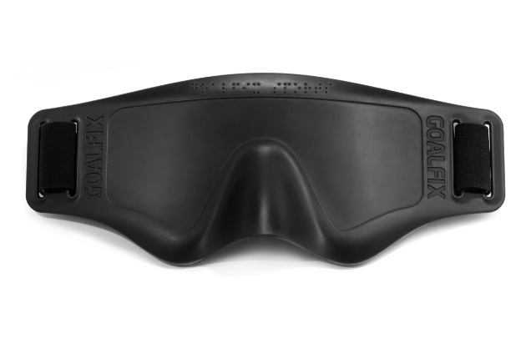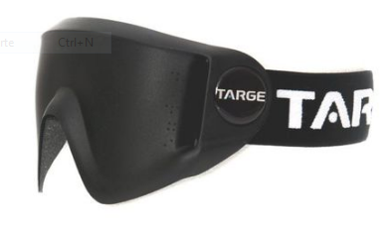

APPENDIX II

HOW TO PATCH A BLIND FOOTBALLER

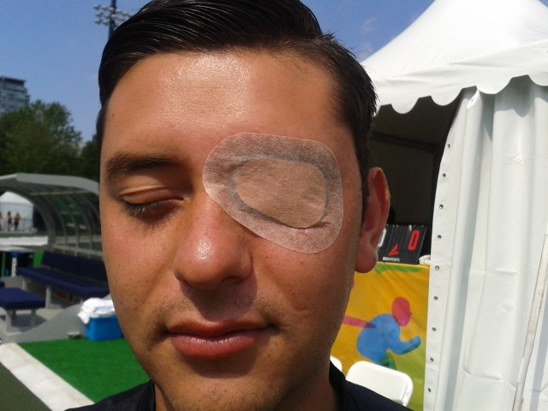 step 1
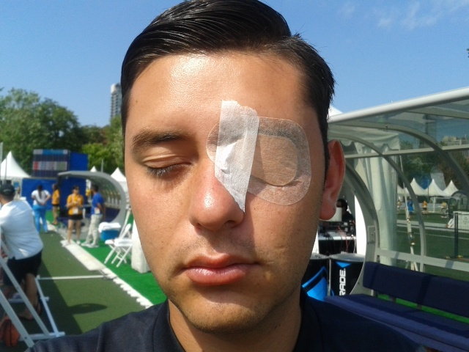 step 2
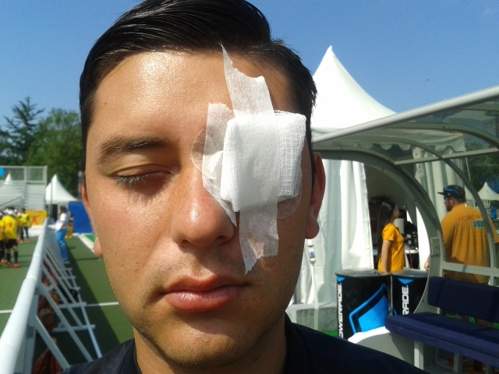 step 3

Eye patches will be checked by the referees in the dressing room before warm-up, at the beginning of each half, after time-outs and before substitutions. The referees may check them at any time during the match at their own discretion.

FREQUENTLY ASKED QUESTIONS
AND IBSA FOOTBALL RESPONSES

LAW 1: THE FIELD OF PLAY

- Can a match be placed on a grass pitch or an artificial grass pitch?

Yes, as long as the playing surface has been approved by the IBSA Technical Delegate.

- Where should the substitutes’ bench be?

The substitutes’ bench should be placed off the field of play and on the same side of the pitch as the timekeeper’s table and the substitution central door. Substitutes and team officials will always use the bench nearer the half of the pitch their team is defending at the time.

- How big should the safety zone behind the goal lines be?

For the players’ safety, the minimum distance between the goal lines and any obstacle is 2 (two) metres.

LAW 2: THE BALL

- What should the referee do if the ball stops completely and none of the players can find it?

Play must not be stopped; the referee should move the ball a little so that it begins to make a noise again and the players can find it.

LAW 3: NUMBER OF PLAYERS

- If during a substitution the player refuses to go out, what should the referee do?

The referee will continue the match, because in order to complete a substitution first the player must go out, and then the substitute player could enter.

- If a goalkeeper is sent off, does that team have to play for two minutes without a goalkeeper? *

No. An outfield player has to leave the match for two minutes (except for the conditions laid out in law 12) so that the substitute goalkeeper can enter. When the period is over and the ball is out of play, the team can get back to its full strength and even the player who was taken off to let the substitute goalkeeper play can come back on.

- If a team’s two goalkeepers are injured or sent off, what should the referee do?

He should allow any of the team officials to play as goalkeeper, provided that official was on the squad list handed in before the match. In case of a national team, the team official must be of the same nationality of the team in order to replace a goalkeeper.*

- What is the maximum number of players and officials a team can include in its squad list in B1? *

A maximum of fifteen people and all of them should be mentioned at the official score sheet

- When could a player enter or re-enter? *

A player could enter or re-enter into the pitch when the ball is not in play and with the authorization of the referee or the second referee.

- If a doctor enters to treat a player, should the player go out?

Yes, the player has to leave the pitch and a substitution could be made. The player could re-enter at the next stop of the game. The exception is the goalkeeper that could remain.

LAW 4: PLAYERS’ EQUIPMENT

- Do goalkeepers have to wear shin guards?

Yes.

- Could a player use tape in order to cover up jewellery? *

No, players could not use or cover up any kind of jewellery

LAW 5: REFEREE

- What should the referee wear normally?

A jersey or shirt, shorts, socks and shoes.

LAW 6: ASSISTANT REFEREE

- What should the assistant referees wear normally?

A jersey or shirt, shorts, socks and shoes.

LAW 7: TIMEKEEPER

- When should the timekeeper start the clock? When the referee blows his whistle or when the ball is moved? *

The timekeeper should start the clock when the referee blows his whistle.

LAW 12: FOULS AND MISCONDUCT

- When the ball is in play at the opposite side, is it a foul if the goalkeeper leaves his area?

No, it’s only considered a foul if he/ she participates actively in the match, either physically or verbally, when he is outside his goalkeeper’s area. If he guides a team mate that is outside the goalkeeper’s third in a way that interferes in the match, play would not be stopped, the goalkeeper will be warned, and if he continues in that way he will be sanction with a yellow card. No personal foul will be awarded to him.

- A goalkeeper takes a goal clearance and the ball goes over the half-way line without touching his half of the field of play. What should happen?

It is not a personal foul for the goalkeeper and play should be stopped and restarted with an indirect free kick, to be taken from any point on the half-way line.

- The goalkeeper picks up the ball when it is in play and throws or kicks it beyond the half-way line without touching his half of the field of play. What is the foul?

It is not a personal foul for the goalkeeper and play should be stopped and restarted with an indirect free kick, to be taken from any point on the half-way line. *

- If a goalkeeper’s hand leaves the goalkeeper’s area accidentally during a goal clearance, is it a penalty?

No.

- If a goalkeeper kicks the ball beyond the half-way line and the ball bounces or touches his/ her half of the field of play and then enters the opposing team’s goal, what should the referee do?

He should award a goal clearance to the opposing team.

- What should the referee do if, as a result of injuries or sending offs, a team is left without guides?

He should allow anyone on the squad list to perform the duties of a guide, and if this is not possible, to continue without a guide.

- If a guide, goalkeeper or coach gives his/ her players instructions outside his/ her third when the ball is out of play, is it a foul?

No, but as soon as the referee indicates play should restart none of them can give instructions to his/ her players outside his/ her third.

- Could a goalkeeper go out from his/her goalkeeper’s area, when the ball is not in play, in order to organize the defensive barrier?

Yes, he/ she must do it quickly.

- What should the referee do if a substitute, a team official or a guide breaks the laws of the game when the ball is in play?

If the referee stops play because of this, the referee could sanction this person, yellow or red card, not any time of foul (nor personal, nor team foul) will be awarded, and play should be restarted with an indirect free kick, to be taken from the place where the ball was. (Law 13 – Position of free kick).

- If a player is alone, slides to stop the ball and then stands to play the ball, is it a foul?

No, as soon as the player is alone and does not take any advantage of sliding from an opponent.

- If a player is alone, holding the kickboards with both hands and playing the ball, is it a foul?

No, as soon as the player does not take any advantage against the opponents.

- If one team is obviously not attacking in 40seconds, which is the procedure to follow? *
Any time after the completion of 40 seconds, the Referee starts countdown saying loudly “five” and showing with his/her raising hand the remaining seconds from 5 to 0. The team possessing the ball should start an attack in these 5 seconds. If an attack is not started in five seconds, then the referee blows the whistle showing a personal foul to the possessor of the ball. The game will restart with an indirect free kick from where the ball was for the opposing team.
- If the referee plays the advantage although a foul was committed, how shall he/she restart the game when the ball is out of play, no matter if a goal is scored or not?

The referee could sanction the player, if is needed. No accumulative or personal foul will be awarded, and restart the match as it finished.

LAW 13: FREE KICKS

- Can a goalkeeper take free kicks?

No, not even at his/ her goalkeeper’s area.

LAW 14: ACCUMULATED FOULS

- If, after the fifth accumulated team foul, the referee awards a direct free kick, double penalty process, closer to the goal than the second penalty spot and the kicker and coach do not agree where it should be taken from, what should the referee do? *

The referee will allow the kicker to decide.

LAW 15: PENALTY KICK

- Can a goalkeeper take penalty kicks?

No.

LAW 16: KICK-IN

- Can a goalkeeper take a kick-in?

No.

SANCTIONS IN A TOURNAMENT SERIES *

- Two yellow cards against the same person in different games of the same stage of a tournament, automatically suspends the person from the next game.

- Two yellow cards against the same person at the same game, automatically suspends the player from the next game.

- A yellow card at one stage of a tournament does not transfer to the next stage of the tournament.

- A direct red card at a game, automatically suspends the person from the next two games.

- If a person sanctions twice with a red card at the same tournament for trying to obtain advantage from light perception, this person automatically suspended for the remaining of the tournament.

- If there is a stronger situation, such as a racial insult/ a physical aggression etc., a disciplinary committee will decide the sanction to the person. This sanction could be minimum 2 matches and it will depend on the type of aggression. *

- A remaining sanction of a red card, transfers automatically to the next official games (World Championship/ IBSA Regional Championships/ Qualification Championships for official events as Paralympics and IBSA World Championship/ IBSA World Games/ IPC Paralympic Games).

