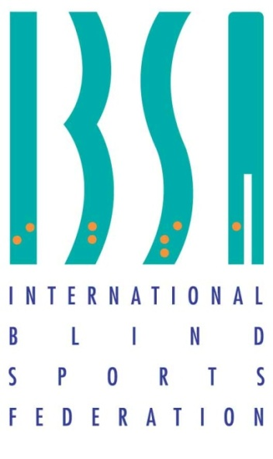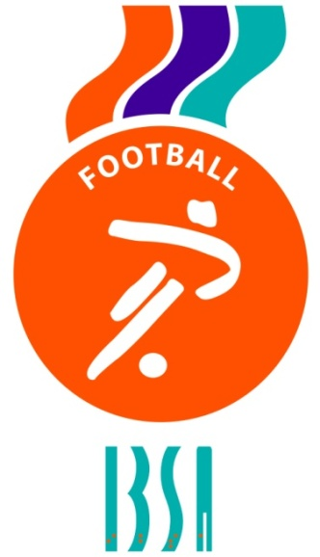

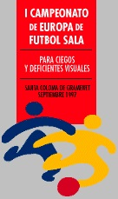

1st IBSA BLIND FOOTBALL (B1 category) EUROPEAN CHAMPIONSHIPS 1997
BARCELONA, SPAIN
SEPTEMBER 16th-20th

Tuesday 16th September
Greece 1 Great Britain 0
Italy 3 Portugal 1
Wednesday 17th September
Italy 0 Great Britain 2
Spain 1 Greece 0
Great Britain 3 Portugal 2
Italy 0 Spain 6
Thursday 18th September
Greece 2 Italy 4
Portugal 0 Spain 4
Friday 19th September
Portugal 0 Greece 2
Spain 0 Great Britain 0

Saturday 20th September
Final - Spain 1 Greece 0

Final standings
1 Spain
2 Greece
3 Great Britain
4 Italy
5 Portugal

