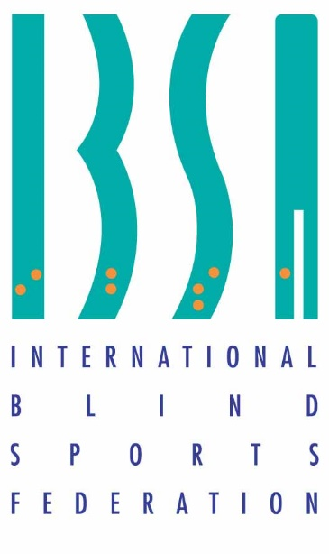

IBSA BACK TO COMPETITION
FOOTBALL SPORT GUIDELINES
IN TIMES OF COVID-19

This document imposes additional obligations on everyone who is participating in an IBSA Football competition during COVID-19. The rules, policies and procedures identified in this document will be enforced just like any other provisions in IBSA’s football rules of play until such time as an effective and proven vaccine for COVID-19 is discovered and is made readily available throughout the world. Protests and appeals related to the content of this document shall be conducted in accordance with IBSA’s protest and appeal procedures. Please note that this is a document which can be updated according to current changes and requirements.

Contents
- Introduction
- Preliminary Organisation Measures
- Mandatory attendance register
- Volunteer duties
- Arrival in Host Country/Hotels
- Transport
- Classification
- Competition Venue
- Before the game
- Patching and monitoring eyeshades
- Physical distancing
- During the game
- Medical assistance
- After the game
- Anti-doping
- Medal ceremonies
- Appendix 1. COVID-19 symptoms
Appendix 2. Hygiene and Infection Control Recommendations
Appendix 3. Waiver of Liability
Appendix 4. COVID-19 Health Declaration

- Introduction
This document has been developed to support the safe return to IBSA Football competition activities, in response to the COVID-19 pandemic. These guidelines are defined for all the stakeholders including athletes, team staff, officials and other staff including spectators involved in Football competitions to prevent COVID-19 infection. These countermeasures are also intended to support event organisers and all IBSA sanctioned competitions will be operated according to these guidelines. The main objective is to reduce contact between teams, officials and other participants and use facemasks, sanitizers and disinfection accordingly. Sanitization of the equipment and the playing area including toilets, changing rooms, entrance and exit points will be required according to the guidelines. The LOC must also follow national regulations and inform IBSA Football at least 60 days before the start of the competition, regarding any additional requirements which need to be put in place before an IBSA sanctioned event. This document contains both COVID-19 specific recommendations as well as general recommendations on hygiene and infection control. Once the situation changes with regards to the COVID-19 pandemic this document will be revised accordingly, with immediate consequences of the applied rules if another time frame is not given.

It is everyone’s individual responsibility to protect his or her health and the health of others by every possible means including the ones mentioned in these guidelines. IBSA assumes no liability and any damages arising as a result if any individual contracts COVID-19, even if these rules are followed precisely.

- Preliminary Organisation Measures

Mandatory attendance register
A Safety Officer must be assigned by the LOC and/or IBSA to keep an updated register with all the people enrolled in the competition: volunteers, athletes, team support staff, etc. It should include the register of incoming day and hour, and outgoing day and hour, direct individual mobile phone contact - mandatory (and in the case of teams the Protocol Compliance Officer mobile phone contact), areas where he/she walked, accommodation location / room number, people in the same room, guides, in order to fulfil an eventual need of an epidemiological inquiry. The forms should be marked private and confidential and treated as personal health information under the applicable IPC International Standard related to the protection of health information. These records should be destroyed within three weeks after the event, unless there are any pending protests or appeals. In such a case, the records will be destroyed within three weeks of the protest or appeal being concluded. If there are any suspected or confirmed cases (one person) and outbreaks (more than one person) they must be reported to the Safety Officer, LOC who will inform the country’s Health Authorities immediately and the Technical Delegate. All participants shall be informed as per instructions from the appropriate Health Authorities of that country. If the country where a competition is held has a Covid-19 tracing application, attendees may be required to install it on their mobile phones.
The Safety Officer is the lead of the process concerning all these safety rules in times of the COVID-19 pandemic and should make sure that all those guidelines are respected and should work closely with the transport manager, volunteers and the venue manager as well as the IBSA Technical Delegate.

Volunteers
There should be at least three volunteers to make sure that the sanitation guidelines are adhered to by verifying that the athletes and their accompanying persons follow the rules and that all hygiene tools are in place. Non touch rubbish bins with closed lids to help contain contaminants are highly recommended. Rubbish bins should be cleaned with disinfectant, lined with a plastic liner and emptied after each half day. All sanitizers should be frequently checked and stocks replenished and they should be vigilant that all participants are using these at all times. No food or drinks should be brought in except for water personally carried in by each participant.

LOC /the venue should have their own staff for cleaning bathrooms. Taps, sink bowls, toilets to be cleaned/disinfected at least two times during each half day-session. Use disposable, one-use sanitizing tissue for each separate high-touch surface. A thorough cleaning of all facilities in use should be done at the end of each half-day period with disinfectants.

- Arrival in Host Country/Hotels

Airport arrivals
It is imperative that each team attending an IBSA Football competition is fully aware of the arrival airport’s regulations in relation to their country and be sure to verify any recent changes before they depart. COVID-19 measures frequently change within short notice and IBSA or the LOC cannot be held responsible if teams are put into quarantine or if the necessary COVID-19 tests have not been performed in advance by the team. The LOC should communicate the relevant Covid-19 protocols at the airports and hotels to all nations attending the competition to make sure that everyone is aware of their obligations.

Hotels
Each hotel will have specific hygiene and safety regulations in COVID -19 times. These regulations must be observed on arrival and throughout the stay of every participant. However, buffet is not recommended (both at hotels and at competition venues) because of not only crowding and queuing aspects but also because of the obvious hygiene problems of many people touching the serving spoons and dishes.
- Transport
Transport provided should not mix different national teams and other people and therefore LOC are obliged to provide adequate transport for arrivals of teams and throughout the competition. A transport manager should be appointed for the duration of the competition and work closely with the Security Officer to make sure all regulations on the transport are adhered to:
- Hygienizing alcohol (80%) or sanitizing alcoholic gel mix should be accessible on all transport. Each person entering (upon each entry), and leaving (upon each departure) should sanitize their hands;
- All people must stay seated with masks on at all times. (See note regarding masks in Appendix 2);
- Cough etiquette is imperative at all times. This means covering your mouth and nose with your bent elbow or tissue when you cough or sneeze;
- No one who is guiding an athlete should use their bent elbow;
- Volunteers will not guide athletes; teams must provide support staff to fulfil this role.

- Classification
Classification will take place at designated IBSA sanctioned competitions
and will strictly follow the ibsa Classification Hygiene and Infection Control Guidelines in times of COVID-19. See:
https://www.ibsasport.org/news/2041/ibsa-releases-guidelines-for-safe-sight-classification
The ibsa Classification Hygiene and Infection Control Guidelines have been developed to support the safe return to classification activities in response to the COVID-19 pandemic.

- Competition Venue – Field of play

Technical Meetings:
*All the Technical Meetings will be online

Prevention Measures:
*Every National Federation/NPC/team must have a health and travel
insurance in case of COVID-19 to cover all the expenses related to medical
attention, meals, accommodation and transportation.
*Every National Federation/NPC/Team must appoint a Protocol Compliance
Officer who is responsible for ensuring general hygiene and social
distancing measures are respected at all times. The Protocol Compliance
Officer will be the contact person with LOC and with the Safety Officer.
*All the members of the teams, the Technical Delegate and all the Technical
Officials will have their temperature tested every day before departing from
the hotel to the pitch. If the body temperature of one person is higher than
37.5, he or she will have to sit down and rest for 20 minutes. After 20
minutes, the body temperature will be tested again. If it continues to be
higher than 37.5, he or she will have to stay at the hotel in a single room.
The situation will also be reported to the Safety Officer immediately.
*LOC must have individual rooms available to be used in case of a person
discovered with COVID-19 symptoms.

Before the Game
- 2 sanitizers must be available at all entrances to the venue where volunteers will be on hand to make sure that everyone has a face mask and they use the sanitizer;
- All people have to wear facemasks inside the venue. The exception is the players and the two technical officials (referees) on the field of play;
- Hand sanitizer, facemasks and disposable gloves have to be present at the official table at all times;
- Participants should arrive at the facility in sports kit and when shower facilities and changing rooms are closed should go back immediately to the hotel;
- No hand shaking at any time is allowed, including at coin-toss;
- There is a need for disinfection after each game;
- Supplies of the following must be made available by the LOC at all times
during the event: facemasks; non allergic latex disposal gloves; hand
sanitizers; garbage bags; paper towels; cleaning wipes; spray
disinfectants;
• Follow all rules put in place by venue operators including local health
regulations. This may include limited or no use of washrooms, change
rooms and other areas. It may include coming to the program dressed
ready to participate and immediately after;
- With regard to spectators in the venues or whether the attendance is restricted to only those participating in the competition and related support staff, the LOC must be guided strictly by the laws of the Local Health Authorities.
- Match reports: staff must not sign the match reports. Referee Coordinator will send by email the match report to each team 40 minutes after the match finished. Teams will have until one hour after the match has finished to send an email in order to claim about the match report.
- LOC will send photos of each team member accreditation card to Referee Coordinator by email (so referees will not need to ask for the players accreditation card at every match and we will avoid touching them every day).

Patching and monitoring eyeshades
- Teams will be responsible for any patching;
- Technical Officials will check the inside foam of the eyeshades wearing gloves;
- Technical Officials will check the eyepatches by standing in front of the players and saying “Referee Control”. Players will have to put up the eyemasks by themselves to let the Technical Officials to check the eyepatches;

- Each player will have to wear his/her own eyeshade. LOC will not provide eyeshades. Players are not allowed to interchange eyeshades with team mates. LOC will provide replacement eyeshade foams. IBSA Official approved eyeshades can be checked on the following link: https://www.ibsasport.org/sports/files/1091-General-IBSA-Blind-Football-approved-equipment-as-of-November-2019.pdf

Physical distancing
- Off court and out of game social distancing of 2m must be vigorously sustained;

- Different pathways for teams (before and after the game) will be created to maintain physical distancing;

- Officials and spectators should avoid closed spaces (less than 1.5 meters between each person);

- Table officials will be repositioned to maintain social distancing;

- Warm up area to be restricted to maintain social distancing between teams;

- Increase bench area space to allow for social distancing;

- There will be 2 safety zones:

ZONE A: 3 metres from the pitch and from the control table. Only
the 2 teams playing the match, the IBSA Technical Delegates, the
LOC Sport Manager and the ITOs are allowed to be in this zone.
Everyone must wear facemasks. No food or beverages are allowed
inside this Zone (exception at the substitute benches).

ZONE B: 5 metres from the Zone A. This zone is for mass media,
volunteers, ball children, medical team. Everyone must wear
facemasks. No food or beverages are allowed inside this zone.

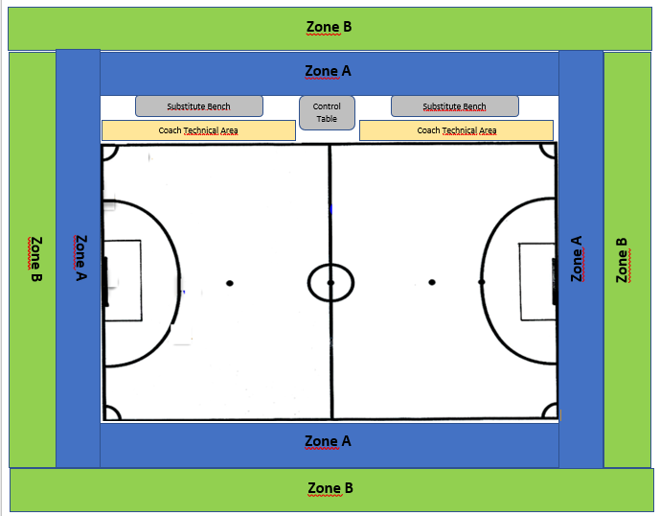

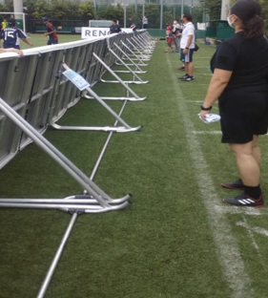

Zone A

- Substitutions: players will be guided off and onto the pitch using the voice of coach or officials;

- Coaches´ Technical Area: only the person coaching can be at this area. If a translator is needed to talk to the players, he/she is allowed to be inside this area too. However, only one person can be without facemask.

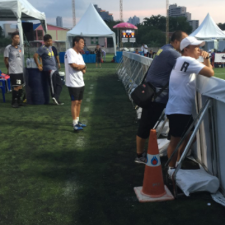
Example of Coaches´ Technical Area:
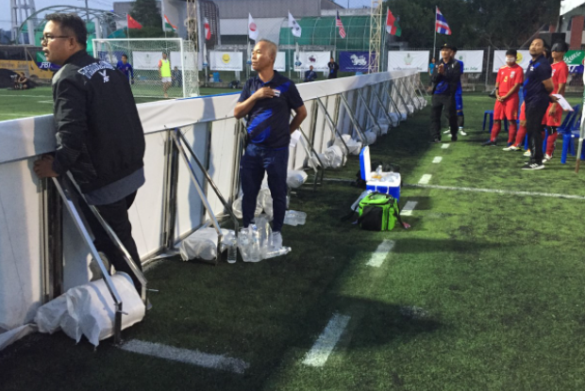
During the game
- Table officials have to wear facemasks and sanitize all equipment before and after use (stopwatches, scoreboard, etc.);
- No food or beverages are allowed at the control table;
- No food or beverages are allowed at the coaches´ technical area;
- Substitutions: there will be no substitutions boards. Coaches will have cards with numbers to show to the third referee the number of the player who is going out. Substitutions will be made at the corner point, in order to avoid touching the central door:
- Facemasks can be removed when coaching from the Coaches´ Technical Area;
- Facemasks must be worn by the guides at all time, including during line ups and time outs. Only inside the guides´ areas during the match the guides are allowed to be without the facemask;
- Facemasks will not be worn by players when they are on the pitch participating in a match but must be worn everywhere else;
- Facemasks will not be worn by the technical officials (referees) when they are on the pitch participating in a match but must be worn everywhere else;
- At the end of the first half and at the end of the match the goalposts, the side boards, the substitute benches and the balls must be cleaned and disinfected;
- The official ball-children must wear facemasks and gloves;
- Players, goalkeepers and staff must avoid spitting;
- Goalkeepers must avoid spitting on their gloves.

Medical assistance
- Medical personnel will take up a position on the other side of the court in a marked-out area with PPE: face mask, gloves, eye protection, and apron, already applied ready to respond to an incident. If appropriate, the mask to be applied to patient too;
- Facemasks must be worn when delivering first aid or medical support;
- Medical timeouts must be extended to allow for new PPE to be applied to the medical personnel before retaking up their position.

After the game
- No hand shaking at any time is allowed;
- Disinfection of the FOP, official’s table, team bench area and dressing rooms must be completed before the next game begins;
- The game ball must be disinfected after each game.

Important: Everyone must understand that they may be subject to removal from a session or entire competition if they do not comply with these rules.

- Anti-Doping
Anti-doping procedures will be conducted according to the most recent COVID-19 protocols:
https://www.wada-ama.org/en/resources/doping-control-process/COVID-19-ado-guidance-for-resuming-testing

8 Medal Ceremonies
Medal ceremonies cannot be carried out as normal due to the proximity of medal and gift presenters to athletes during the awarding.
Presenters
Only one person will present the medals and the gifts, and this must be the same person for each medal and medal event taking place on one day.
Medal presenters must wear masks and gloves during the presentation. They may step aside and remove their masks for photos at the end of the ceremonies only.
Medals will be presented to all medallists on trays or cushions by one person only. This is to avoid presenters coming into close contact with athletes, and to minimise the number of people present during the presentation. However, if the medal presenter is blind and requires a guide which frequently happens in IBSA sports, an exception should be made.

Ceremony – team medals
There will be three trays only: one set of bronze, silver, gold medals for each team.

- Presenter moves across the podium towards the relevant team and stands in front of them.
- Presenter moves tray or cushion towards the coach.
- The coach should pick up all the medals for the team.
- Presenter moves to the side of the podium for the national anthem.
- Athletes and presenter remain in place for photos (athletes remain in their podium spots, no joining with other countries or competitors).
- Athletes and presenter depart the podium in separate directions.

APPENDIX 1 - COVID -19 Symptoms

Watch for symptoms of COVID-19 that can appear up to 14 days after
being exposed to the virus. The symptoms of COVID-19 are similar to
other respiratory illnesses including the flu and common cold. The most
common symptoms of COVID-19 include:
• Fever*
• Chills
• Cough or worsening of chronic cough
• Shortness of breath
• Sore throat
• Runny nose
• Loss of sense of smell or taste
• Headache
• Fatigue
• Diarrhoea
• Loss of appetite
• Nausea and vomiting
• Muscle aches
While less common, symptoms can also include:
• Stuffy nose
• Conjunctivitis (pink eye)
• Dizziness, confusion
• Abdominal pain
• Skin rashes or discoloration of fingers or toes.
*Average normal body temperature taken orally is about 37°C.

https://www.who.int/emergencies/diseases/novel-coronavirus-2019/question-and-answers-hub/q-a-detail/q-a-coronaviruses

Appendix 2. Hygiene and Infection Control Recommendations

- Physical distancing

Maintain a physical distance (a minimum of 2 metres or a greater distance if stipulated by the national health authority) from other individuals.

https://www.who.int/westernpacific/emergencies/COVID-19/information/physical-distancing

- Hand washing

Performing hand hygiene frequently with an alcohol-based (80% v/v for ethanol or 75% v/v for isopropyl) hand rub and if your hands are not visibly dirty or with soap and water if hands are dirty; provide clear instructions to classifiers on hand washing, specifically when classifiers and athletes should wash their hands.

- Hand hygiene:

https://www.who.int/infection-prevention/campaigns/clean-hands/WHO_HH-Community-Campaign_finalv3.pdf?ua=1

https://www.who.int/gpsc/clean_hands_protection/en/

https://www.who.int/infection-prevention/tools/hand-hygiene/en/
- Hand sanitisers:
https://www.who.int/gpsc/5may/Guide_to_Local_Production.pdf?ua=1
- Non-latex gloves

Gloves are not a substitute for hand hygiene. Gloves that are removed should not be put back on. It is also recommended that guides should wear gloves when accompanying the athlete.

How to safely remove gloves:

https://www.globus.co.uk/how-to-safely-remove-disposable-gloves.

- Face masks
Medical masks must be worn by all participants in the competitions apart from the players and the officials (referees) when they are on the court participating in a match. For an accompanying person and/or translator a non-medical face mask can be considered (i.e., something constructed to completely cover the nose and mouth, without gaps, and secured to the head by ties or ear loops). Therefore, provide clear instructions on how to safely put them on and remove them. See WHO guidance:

https://www.who.int/images/default-source/health-topics/coronavirus/risk-communications/general-public/protect-yourself/infographics/masks-infographic---final.tmb-1920v.png

https://www.who.int/emergencies/diseases/novel-coronavirus-2019/advice-for-public/when-and-how-to-use-masks

- Cough etiquette
This means covering your mouth and nose with your bent elbow or tissue when you cough or sneeze. Then dispose of the used tissue immediately and wash your hands.
https://www.who.int/images/default-source/health-topics/coronavirus/risk-communications/general-public/protect-yourself/blue-3.png?sfvrsn=b1ef6d45_2

- Cleaning and disinfecting surfaces
Surfaces should be cleaned with soap and water or a detergent to remove organic matter first, followed by disinfection. Use ethanol at a concentration of 70%-90%, or sodium hypochlorite (bleach) at a concentration of 0.1% (1000 ppm).
https://www.who.int/publications-detail/cleaning-and-disinfection-of-environmental-surfaces-inthe-context-of-COVID-19
Appendix 3

WAIVER OF LIABILITY FOR ALL CLAIMS AND RELEASE OF LIABILITY
PLEASE READ CAREFULLY BEFORE SIGNING.

Completed waivers must be returned with registration or prior to attending any IBSA sanctioned competition to the LOC.

By signing below, the Participant (named below) and/or the Participant’s Guardian who represents that the Participant confirms that:
1. Has not travelled internationally during the last 14 days;
2. Has not visited a COVID-19 high risk area, region or location during the last 14 days;

3. Does not knowingly have COVID-19;
4. Is not experiencing known symptoms of COVID-19, such as fever, cough, or shortness of breath, and if experiences such symptoms during the Event will immediately depart from the Event;

5. Has not, in the past 14 days, knowingly come into contact with someone who has COVID-19, who has known symptoms of COVID-19, or is self-quarantining after returning to their home country;

6. Will follow government recommended guidelines in respect of COVID-19, including practicing physical distancing, and will do so to the best of the Participant’s ability during the Event;

7. Will follow the rules and guidelines put in place by the organization.
- In addition, by signing below the Participant and/or the Participant’s Guardian understands, acknowledges and assumes the inherent risks in participating in this activity or event, including, but not limited to: the potential for bodily injury or illness (including contraction of COVID-19 contact or interaction with others who may have been exposed to COVID-19.

- In consideration for allowing the Participant to participate in the Event, the Participant and/or the Participant’s Guardian:

(a) releases, discharges and forever holds harmless the Organization from any and all liability for damages or loss arising as a result of the risks of participation in or in connection with the Event;
(b) waives any right to sue the Organization in respect of all causes of action (including for injuries or illness caused by their own negligence),claims, demands, damages or losses of any kind that may arise as a result of the Risks of participation in or in connection with the Event, including without limitation the right to make a third party claim or claim over against the Organization arising from the same;
(c) freely assumes all risks associated with the risks, anything incidental to the risks, which may arise as a result of participation in or in connection with the Event.

PLEASE BE AWARE YOU ARE GIVING UP LEGAL RIGHTS TO ANY AND ALL FUTURE CLAIMS AGAINST THE ORGANIZATION.

I confirm that I have read and fully understand this waiver and release of liability. I sign this waiver and release of liability voluntarily without any inducement, assurance, or warranty being made to me.
Print Name: _______________________________

Date of Birth: ________________________

Print name: ________________________________________
The “Guardian” (if Participant is a minor)

Signature: _________________________________________ Date:
Participant or Guardian for minor

This waiver will be interpreted in accordance with the laws of Germany.

Appendix 4

COVID-19 AND HEALTH DECLARATION*
Separate forms to be completed by each athlete and support personnel attending this IBSA sanctioned competition.

The health and well-being of all is our highest priority. As a result of the COVID-19 outbreak, we are applying screening processes and hygiene measures to safeguard athletes, their support staff and classification personnel. As a condition of proceeding with your participation in this IBSA sanctioned event, please answer the questions below and adhere to the additional hygiene processes requested of you.
SELF-DECLARATION | YES/NO
Are you presenting with any of the following symptoms relating to COVID-19?
- Fever
- Cough
- Shortness of Breath
Have you in the past 14 days been in contact with someone diagnosed with coronavirus to your knowledge?

If you respond ‘YES’ to any of these questions, then as a precautionary measure, you will be unable to proceed with participation at this time. We ask for your full support as we all have a shared responsibility to minimise the risk of exposure and protect our individual and collective health.

NAME

COUNTRY

IBSA MEMBER - NPC/Association

SIGNATURE SIGNATURE OF GUARDIAN

DATE

*Self-declaration records will be used and disclosed for managing participation at an IBSA sanctioned competition during the risk period only and as required by local health regulations. Records will be kept securely and retained for a period required under our retention schedules in compliance with privacy laws and regulations. Please let us know if you have any questions or concerns and thank you for your co-operation.

