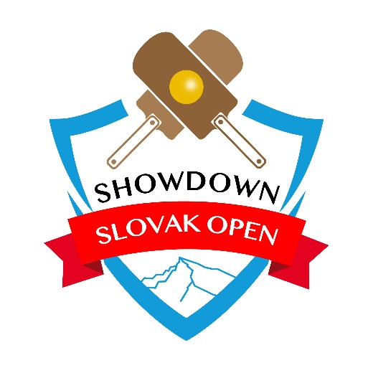

Blind Sports Club Slovakia in cooperation with Slovak Association of Visually Impaired Athletes would like to invite you all to:

**Third edition of International Showdown Tournament**

**„Showdown Slovak Open 2025“**

Samorin, Slovakia, February 26th – March 2nd, 2025

1. **Place of Competition, accommodation, meals**

All participants will be accommodated in X – Bionics Sphere Hotel in Family units – each unit has 2 bedrooms and 1 bathroom, maximum capacity: 4 people for a unit.

Full board will be provided at the same place. All meals will be served as a buffet.

We will play at the conference section of the same hotel.

**Web**: <https://www.x-bionicsphere.com/en/>

1. **Organizing Committee**

**Tournament Manager**: Jan Šenítko

**Communication Manager**: Markéta Kisiel

**E-mail**: [showdownslovakopen@gmail.com](mailto:showdownslovakopen@gmail.com)

1. **Arrival, departure, transportation to/from the hotel**

**Arrival**: Wednesday, February 26th (before 5 pm if possible)

**Departure**: Sunday, March 2nd (after breakfast)

The nearest airport is in Bratislava, Slovakia, another close enough is Vienna Schwechat Airport, Austria.

Other possible ways how to get to Bratislava: by train or by bus.

1. **Schedule**

**Wednesday 26th:**

18:00 – 21:00 Dinner

20:00 Referee Meeting

20:30 Team Leaders Meeting

21:00 Equipment Check

**Thursday 27th:**

7:00 – 10:00 Breakfast

8:00 Opening Ceremony

8:30 – 13:00 Competition

12:00 – 14:00 Lunch

14:00 – 19:00 Competition

18:00 – 21:00 Dinner

**Friday 28th:**

7:00 – 10:00 Breakfast

8:00 – 13:00 Competition

12:00 – 14:00 Lunch

14:00 – 19:00 Competition

18:00 – 21:00 Dinner

**Saturday 1st:**

7:00 – 10:00 Breakfast

8:00 – 13:00 Competition

12:00 – 14:00 Lunch

14:00 – 18:00 Competition

19:00 Closing and Prize Giving Ceremony

19:30 – 21:00 Dinner

**Sunday 2nd:**

7:00 – 10:00 Breakfast

Check out (until 11 am) and departures

*Program may change due to the organizational reasons.*

1. **Registration, participation fee**

Deadline for **registration** is **December 15th, 2024**, to register you must fill the entry form and send it to the following e-mail address: [showdownslovakopen@gmail.com](mailto:showdownslovakopen@gmail.com).

Participation fee:  
**450 EUR** /per person (4 people in the unit),   
**485 EUR** /per person (3 people in the unit),   
**550** **EUR** /per person (2 people in the unit) or   
**750 EUR** /per person (1 person in the unit).   
Maximum one single room per team. This fee includes accommodation and all meals from Wednesday dinner to Sunday breakfast.

**Participation fee** must be paid until **January 8th, 2025**.

After January 8th, 2025 no refund is available.

1. **Transportation**

Transfers are guaranteed **only from/to Vienna Schwechat Airport** and **Bratislava Airport and Train Station** by bus at scheduled time.

Transfer fee from/to Vienna Airport: 30 **EUR/** person.

Transfer fee from/to Bratislava: 20 **EUR/** person.

Travel details must be communicated by e-mail to the Organizers by **January 25th, 2025**.

1. **Other information**

The Tournament will be governed by IBSA Rules.

According to the current IBSA Showdown Rules only B1, B2, B3 players are allowed to play. Players who have not been classified by IBSA have to provide a medical document providing their level of visual impairment.

The document with the classified players is available on IBSA's website.

No time limits will be applied to matches. One point will be awarded for a won match.

Participants will be divided into 2 categories – men and women.

The games will be played on at minimum 5 Czech tables with 10 referees. Danish balls will be used.

We plan to organize live video or audio stream from one of the tables.

**Deadlines Summary:**

|  |  |
| --- | --- |
| Registration | December 15th, 2024 |
| Participation Fee payment | January 8th, 2025 |
| Participation Fee Refund | Until January 8th, 2025 |
| Travel Details | January 25th, 2025 |

In a case of any further questions, do not hesitate to contact us: [showdownslovakopen@gmail.com](mailto:showdownslovakopen@gmail.com)

We are looking forward to meet you in Samorin!

Best Regards,

Jan Šenítko