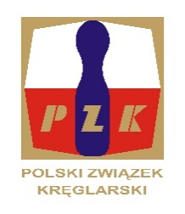
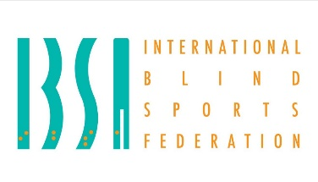

1ST IBSA TEN PIN BOWLING EUROPEAN CUP
FOR BLIND AND VISUALLY IMPAIRED – 17 – 21.11.2024.
Opole, Poland

INVITATION and GENERAL INFORMATION
Dear friends,
The POLISH NINEPIN AND TENPIN FEDERATION in co-operation with IBSA Sports Committee and Polish Start are pleased to invite your blind and visually impaired nine pin bowling players to take part at 1st IBSA TEN PIN BOWLING EUROPEAN CUP FOR BLIND AND VISUALLY IMPAIRED – held from 17th to 21st November 2024., Opole, Poland

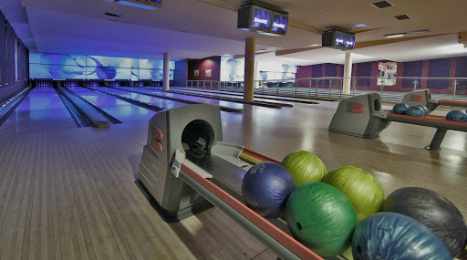

1st IBSA TEN PIN BOWLING EUROPEAN CUP LOC:
HOST: POLISH NINEPIN AND TENPIN FEDERATION
ADRESS: ul. Zwierzyniecka 13/25 60-813 POZNAŃ
All correspondence to LOC should be sent to :
Name: JOANNA STALIŚ
Email: snpzk@interia.pl
DATE OF EVENT:
Arrival date, 17.11.2024
Departure date, 21.11.2024
Training date: 18.11.2024
Competition date: 18.11., 19.11. and 20.11.2024.
HOST CITY : Opole, Poland
ACCOMODATION:
Szara Villa - https://www.szarawilla.pl/

ENTRY FEES:
- 150,00 EURO/per person/day in Single room
- 120,00 EURO /per person/day in Double and Triple room.
The number of single rooms are limited, the organizer will give priority to the first bookings.

BOWLING ALLEY
Bowling alley location
Szara Willa – 12-line https://www.szarawilla.pl/kregielnia
TRANSPORT:
Nearest airport is Prague around 300 km. Transfer fee per person is 40 EUR.
Bus is to leave from Prague on Sunday 17th November around 16:00 CET.
Bus is to leave from Opole on Thursday 21st November around 8:00 CET.
One way Prague-Opole and return may take around 5 hours
Nearest Train Station: OPOLE Distance to Hotel (Kms): 2 KM
Distance from Hotel to Venue (Kms): 0 M

All participants will start with dinner (17. 11.2024 r.) and finish with breakfast (21.10.2024 r.).

CLASSIFICATION:
Medical classifications – 16. And 17. 11.2024 held in Prague (Czech Republic)
Dedicated only for athletes who have outdated and needed review classification status.

Deadline for submitting all the necessary documents i.e. MDF, EF and passport photo must be done by 25th October 2024 at the latest.

IBSA ISAS ONLINE registration of players:
All players participating in the IBSA European Cup 2024 , must be registered in the ISAS database and have a current ISAS Active Sport License for 2024 and IBSA Athlete ID Card. For more information please contact ibsaassist@ibsasport.org .
Since 2018 IBSA has an online registration through the ISAS database for all athletes participating in IBSA sanctioned competitions including this one. This means that you will be able to register your players directly for this competition on the ISAS database. For those IBSA members who are familiar with the IPC SDMS database - the procedure is exactly the same. IBSA members are the only organisation to register their athletes.

For accommodation, the entry forms must be completed as usual but you will not need to write down all your athletes - just staff. IBSA Assist can help you with a powerpoint presentation for you to show the procedure- If you have any problems or need assistance please contact IBSA Assist ibsaassist@gmail.com
Entry by Name must be submitted by: 25th October 2024 at the latest.

IBSA FEE:
- The countries must pay an IBSA Capitation Fee per player. The fee is 25 euro/player and will be payed to LOC of EUROPEAN CUP 2024.
- Each IBSA Member Country must have paid 2024 IBSA Membership Fee.

RULES :
IBSA EUROPEAN CUP 2024 will be organised according IBSA Ten Pin Bowling Rulebook and the latest version of IBF rules.

PAYMENT DETAILS:
The total entry fee shall be paid into our account not later than 31st October 2024
I inform you that payment will be made only by bank transfer. The Polish Ministry of Finance does not accept the cash payment upon arrival in the country.
The banking details are;
Bank account no ( IBAN ):
Swift code : INGBPLPW
Account beneficiary address:
Name: POLISH NINEPIN AND TENPIN FEDERATION
Address : ul. Zwierzyniecka 13/25 60-813 POZNAŃ
Bank name and address:
Name: ING Bank Śląski S.A.
Address: POZNAŃ, POLAND

All the best and see you in Opole,
Tournament Director Joanna Staliś

