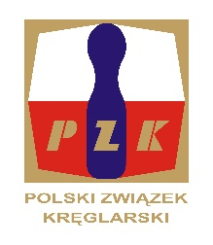
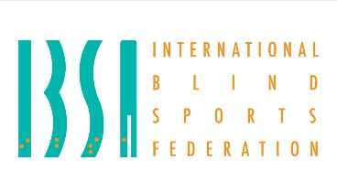
23nd IBSA NINE PIN BOWLING EUROPEAN CHAMPIONSHIP
FOR BLIND AND VISUALLY IMPARIED – 11 – 18.05.2024 r.
Sierakow- POLAND.
Final entry form
NATIONAL ORAGANIZATION:
Address:
Contact person:
Telephone:
E-mail:

Team Competition – MEN
CAT. | Name | Surname | Date of birth | Passport No. | T-shirt Size
1
1
2
2
3
3

Team Competition – WOMEN
CAT. | Name | Surname | Date of birth | Passport No. | T-shirt Size
1
2
3
Notes:
- Substitutions for team event can be decided on the Technical meeting
- Member of the Team can be changed on the Technical meeting

Individual – MEN
CAT. | Name | Surname | Date of birth | Passport No. | T-shirt Size

Individual – WOMEN
CAT. | Name | Surname | Date of birth | Passport No. | T-shirt Size

Technical Staff
Name | SURNAME | Date of birth | Assignment | M/F | Passport No. | T-shirt Size

