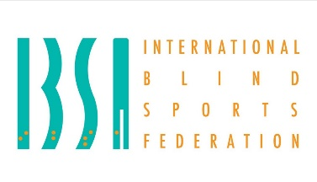
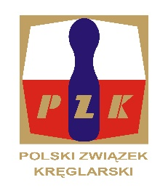
23nd IBSA NINE PIN BOWLING EUROPEAN CHAMPIONSHIP
FOR BLIND AND VISUALLY IMPARIED – 11 – 18.05.2024 r.
Sierakow POLAND.
First entry form(BY NUMBER)
NATIONAL ORAGANIZATION:
Address:
Contact person:
Telephone:
E-mail:

Team Competition – MEN NR:
Team Competition – WOMEN NR:
Individual – MEN B1 NR:
Individual – MEN B2 NR:
Individual – MEN B3 NR:
Individual – WOMEN B1 NR:
Individual – WOMEN B2 NR:
Individual – WOMEN B3 NR:
Technical Staff NR:
TOTAL NUMBER:

