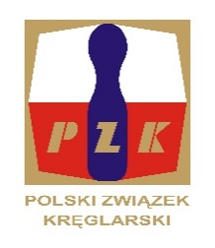
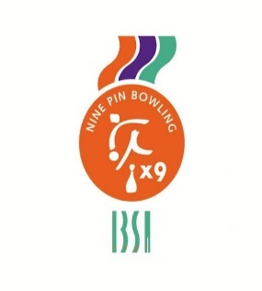
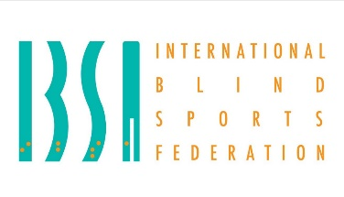

23rd IBSA NINE PIN BOWLING EUROPEAN CHAMPIONSHIP
FOR BLIND AND VISUALLY IMPARIED – 11.05 -18.05.2024
Sierakow, Poland
INVITATION and GENERAL INFORMATION
Dear friends,
The POLISH NINEPIN AND TENPIN FEDERATION are pleased to invite your blind and visually impaired nine pin bowling players to take part at 23rd IBSA NINE PIN BOWLING EUROPEAN CHAMPIONSHIP FOR BLIND AND VISUALLY IMPARIED – 11.05 - 18.05.2024 r.., Sierakow, Poland

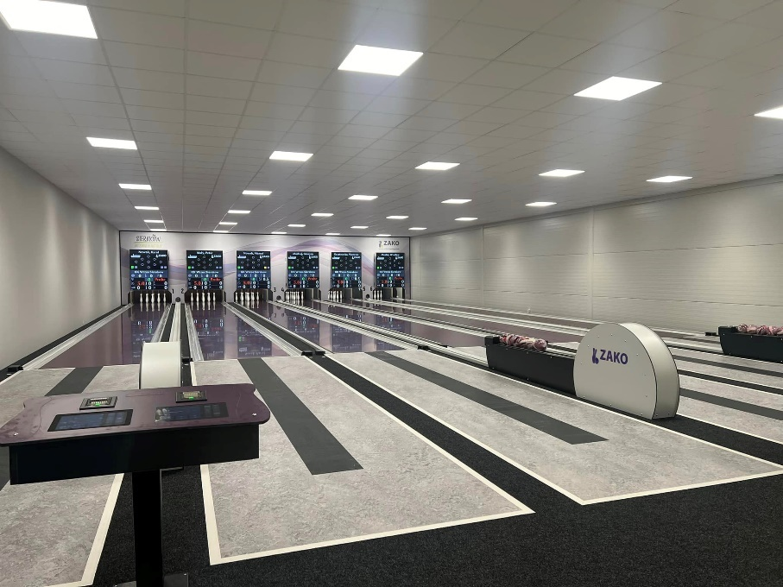

23rd IBSA NINE PIN BOWLING EUROPEAN CHAMPIONSHIP LOC:
HOST: POLISH NINEPIN AND TENPIN FEDERATION
ADRESS: ul. Zwierzyniecka 13/25 60-813 POZNAŃ
All correspondence to LOC should be sent to :
Name: JOANNA STALIŚ
Email: snpzk@interia.pl
DATE OF EVENT:
Arrival date, 11.05.2024.
Departure date, 18.05.2024.
Classification dates: 12. - 13.05.2024
Competition date: 14.05., 15.05., 16.05. and 17.05.2024.
HOST CITY : SIERAKÓW, Poland
ACCOMODATION:
Hotel Kama Park
https://maps.app.goo.gl/zrV6j9kV8sy1jDU57
https://kamapark.pl/
Photos of a single room
https://goo.gl/maps/D43QjdK6VN62
Photos of a double room
https://goo.gl/maps/yqDLxKc3pcS2
Photos of the studio room
https://goo.gl/maps/obrPGMq6ear
Rowan/Acacia Houses:
https://goo.gl/maps/q53pM9xWVtD2
Birch Cottages:
https://goo.gl/maps/d5E4hKdkiWM2
Pine Cottages:
https://kamapark.pl/domki-bungalow/#4

ENTRY FEES:
- 100,00 EURO/per person/day in Single room
- 95,00 EURO /per person/day in Double room.
- 90,00 EURO /per person/day in Studio room 2+2 or 2+1
The number of single rooms are limited, the organizer will give priority to the first bookings.
The entry fee includes participation fee , transport to hotel ( from bus , rally or international airport stations , meals full pension etc.)
BOWLING ALLEY
Bowling alley location
52.63113569101021, 16.099406196712355
https://maps.app.goo.gl/3YuTPQENHCfyfjWG8
Bowling alley, Klub Kreglarski Wrzos, Sireakow
FB: https://www.facebook.com/KlubKreglarskiWrzosSierakow
YF: https://www.youtube.com/@klubkreglarskiwrzos7317

TRANSPORT
Nearest Airport: POZNAŃ ŁAWICA Distance to Hotel (Kms): 70 KM
Nearest Train Station: POZNAŃ Distance to Hotel (Kms): 70 KM
Distance from Hotel to Venue (Kms): 800 M
All participants will start with dinner (11.05.2024) and finish with breakfast (18.05.2024).

CLASSIFICATION:
Planning classification days are: 12.05 and 13.05.2024.
Please read in link below and prepare your team for Classification according to the rules.Players must become familiar with rules and procedures of IBSA medical classification.
( http://www.ibsasport.org/documents/files/68-1-IBSA-Classification-Rules-and-Procedures.pdf).
Medical Diagnostics Form (MDF) and other required medical diagnostics documentation must not be older than 1 year – May 2023 and be uploaded at least 6 weeks before the EUROPEAN CHAMPIONSHIP start – DEADLINE: 31.03.2024

IBSA ISAS ONLINE registration of players:
All players participating in the EUROPEAN CHAMPIONSHIP 2024 , must be registered in the ISAS database and have a current ISAS Active Sport License for 2024 and IBSA Athlete ID Card. For more information please contact ibsaassist@ibsasport.org .
Since 2018 IBSA has an online registration through the ISAS database for all athletes participating in IBSA sanctioned competitions including this one. This means that you will be able to register your players directly for this competition on the ISAS database. For those IBSA members who are familiar with the IPC SDMS database - the procedure is exactly the same.
For accommodation, the entry forms must be completed as usual but you will not need to write down all your athletes - just staff. IBSA Assist can help you with a powerpoint presentation for you to show the procedure- If you have any problems or need assistance please contact IBSA Assist ibsaassist@gmail.com
Entry by number will be: 29 February – 31 March 2024 r.
Entry by Name will be from: 31 March 2024 r.

IBSA FEE:
- The countries must pay an IBSA Capitation Fee per player. The fee is 25 euro/player and will be payed to LOC of EUROPEAN CHAMPIONSHIP 2024.
- Each IBSA Member Country must have paid 2024 IBSA Membership Fee.

RULES :
EUROPEAN CHAMPIONSHIP 2024 will be made according IBSA Nine Pin Bowling Rulebook 2020-2024.

PAYMENT DETAILS:
The total entry fee shall be paid into our account not later than 11th of April.
I inform you that payment will be made only by bank transfer. The Polish Ministry of Finance does not accept the cash payment upon arrival in the country.

The banking details are;
Bank account no ( IBAN ):
Swift code : INGBPLPW
Account beneficiary address:
Name: POLISH NINEPIN AND TENPIN FEDERATION
Address : ul. Zwierzyniecka 13/25 60-813 POZNAŃ
Bank name and address:
Name: ING Bank Śląski S.A.
Address: POZNAŃ, POLAND

MEDICAL INSURANCE:
All members of your delegation MUST have an international travel and personal accident insurance.
KEY DATES for Entry form (excell):
- First entry form: dead line: 26 February
- Total entry fee payment: dead line: 11 April
- Final entry form, Accommodation form, Travel form: 19 April
All the best and see you in Sierakow,
Tournament Director Joanna Staliś

