IBSA WOMEN’S BLIND FOOTBALL TRAINING CAMP AND TOURNAMENT
HEREFORD, ENGLAND, 14th - 18th April 2022
Invitation and Expression of Interest Form

The IBSA Football Committee invites you to take part in an international women’s blind football training camp and tournament in England in April 2022 . The event is part of the IBSA Blind Football Development Project Europe, funded by UEFA, and is organised in partnership with The English FA and British Blind Sport.

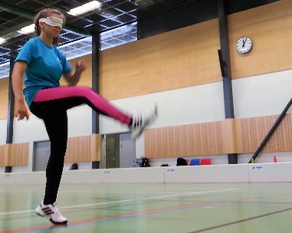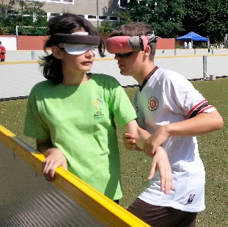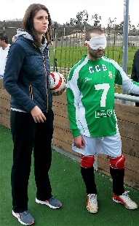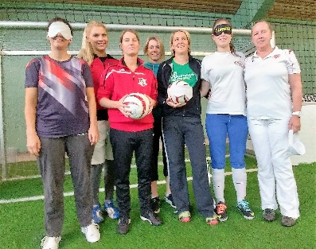

Why?
The goal of the event is to promote blind football for women and girls and the participation of women and girls in blind football in all roles (as players, coaches, guides, referees, support staff, organisers, administrators, etc.).
When?
Thursday 14th April to Monday 18th April 2022.

Provisional programme
Thursday 14th - arrival all participants
Friday 15th - training camp
Saturday 16th - training camp
Sunday 17th - tournament
Monday 18th - departure all participants

Who?
This event is open to visually impaired female players, female and male coaches, referees, guides, support staff, etc., from all IBSA member countries worldwide. While open to both genders, we encourage countries to register female participants. As this event is part of our European development project, priority will be given to participants from Europe when confirming applications.
Where?
The venue for the accommodation, training camp and tournament is:
The Royal National College for the Blind (RNC)
The Point4
Venns Lane, Hereford HR1
England
https://thepoint4.co.uk/
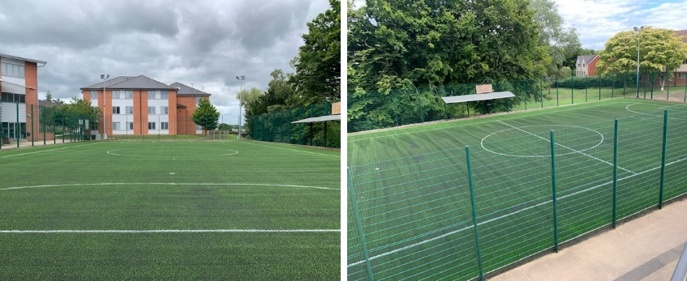

Designated Airport entry point – all participants will be expected to arrive at Birmingham International Airport, a 45-minute journey to RNC, where transportation will be arranged.*
Other airports may be used; however, an additional charge would have to be made to the participant(s) to cover costs:
London – 4 hours to RNC;
Manchester – 2/3 hours to RNC.
Participation, accommodation, meals and transport (* please see note above) are free of charge for participants from IBSA member countries in Europe. Participants only need to cover their own travelling expenses to Birmingham International Airport.
Participants from outside Europe should contact football.eurdev@ibsasport.org and would be charged 360 GBP (90 GBP per night) per person to include transportation to and from the designated airport of entry, accommodation and food costs which are based on three meals per day (continental breakfast, 2-course lunch, 2-course dinner). Participants would also need to cover their own travelling expenses to Birmingham International Airport.

THE DATES FOR THE CAMP AND TOURNAMENT ARE PROVISIONAL DUE TO THE CURRENT COVID-19 PANDEMIC AND THE EVENT WILL BE SUBJECT TO STRICT PROTOCOLS IMPOSED NATIONALLY AND BY IBSA. PARTICIPANTS SHOULD REGISTER THEIR INTEREST BUT NOT MAKE ANY TRAVEL ARRANGEMENTS AS THESE DATES ARE SUBJECT TO CHANGE.

CONFIRMATION OF THE EVENT WILL BE MADE AFTER CAREFUL CONSIDERATION BY IBSA AND THE FA AND BEARING IN MIND NATIONAL GOVERNMENT POLICY AT THE TIME. THE ORGANISERS RESERVE THE RIGHT TO MOVE THE WORKSHOP AS DEEMED NECESSARY AND APPROPRIATE.

APPLICANTS WILL BE INFORMED BY JANUARY 31ST 2022 IF THEY HAVE BEEN SUCCESSFUL IN OBTAINING A PLACE ON THE CAMP.

To register your interest for the event, please complete the expression of interest form below and return to football.eurdev@ibsasport.org by Friday 14th January 2022.
You may also express your interest in participating via the following on-line form:
https://forms.office.com/Pages/ResponsePage.aspx?id=kCXJRcbM-UaA_5_I2e3eOZ-CFFDt00lEizBCCNNU5cBUQkpaTVJIMVdCRjAxSjhJT1A1WDdSTVRIMy4u

EXPRESSION OF INTEREST FORM

Country: __________________________________________________
Organisation: ______________________________________________
Contact person: ____________________________________________
E-mail: ___________________________________________________
Phone number: _____________________________________________

Participants
First name | Surname | Gender (female/male) | Role (player, coach, referee, etc.)

