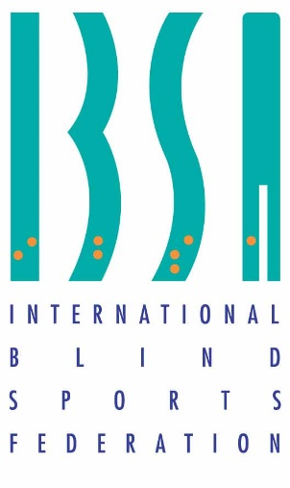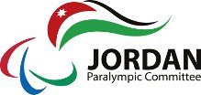

Jordan Paralympic committee  
Hosts the 2021 IBSA GENERAL ASSEMBLY

Dead Sea – Jordan

OCTOBER 10- 12 /2021



Date: 5/1/2021

Dear Sirs,

Warm greetings from Jordan,

I would like to take this opportunity to invite you to attend the ***IBSA*** General Assembly on October 10-12 2021. If you have any questions or comments, don’t hesitate to contact us.

Thank you for your attention to this matter and looking forward to seeing you there.

Regards,

Secretary General

Maha Barghouthi

**Information about the conference**

**Jordan Paralympic committee will host the General Assembly meeting of the International Blind Sports Federation (IBSA) from the 10-12/10/2021 at the Dead Sea – Jordan.**

* 1. **Glimpse of the Dead Sea:**
  2. **The First Natural Spa in the World**

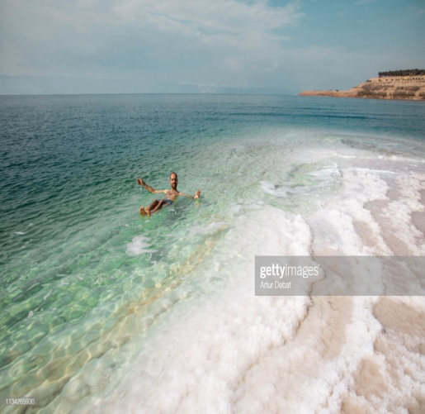

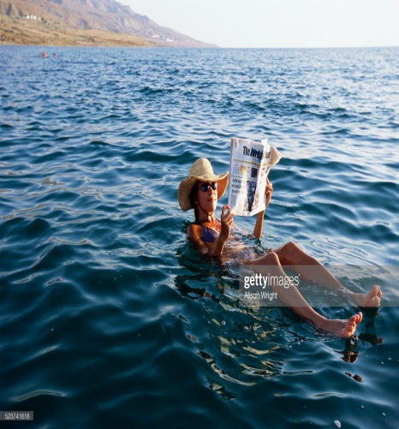

**At 410 meters below sea level, the Dead Sea is the lowest place on earth. A large amount of investment in the area has provided the Dead Sea with new roads and luxurious 4 and 5 star hotels and an award winning conference center.**

**Studies have shown the combination of the Dead Sea water and the rich black muds have significant health benefits such as increasing blood circulation, easing discomfort from arthritis, healing allergies and revitalizing skin.**

**Official Hotel( 5 stars) : Hilton Dead Sea Resort & Spa**

**Conference venue**:

**King Hussein Bin Talal Convention Centre Managed by HILTON**



**Badges:**

**Each delegate will receive a name badge after registration and after paying the accommodation fees. The badge must be worn all the times during the meetings and other activities.**

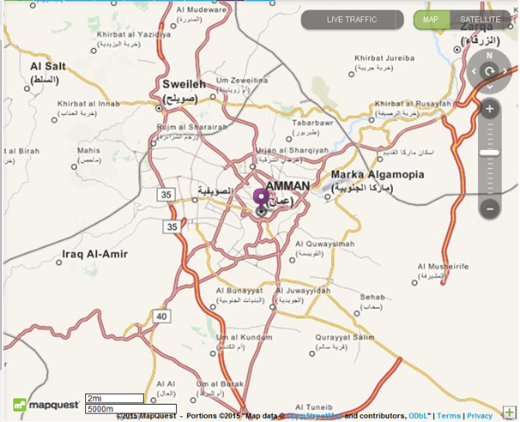

**Currency:**

**The official currency in Jordan is the Jordanian Dinar, which is available in coins and cash. The Jordanian coin categories are: 1/2 dinar, 1/4 Dinar, 50 and 10 fills. The cash is available in different colors and sizes categories: are 1, 5 ,10,20 and 50 dinars.**

**Arrival details:**

**For all countries entering Jordan it is compulsory to pay for their visas in Amman Airport (40$), apart from some countries who require invitation letters and agreements from the Ministry of Interior – Jordan (as listed below).**

**For these countries listed as requiring visas before entering Jordan, please provide us Visa request form and copies of their passports and a passport photo 2 months before arrival to prepare their visas. Without these you will be unable to enter Jordan.**

**Visa request form**

|  |  |  |  |  |  |  |
| --- | --- | --- | --- | --- | --- | --- |
| Name  (Last Name) | (First Name) | Gender  (F/M) | Passport Number | Expiration date  (DD/MM/YYYY) | Date of Birth  (DD/MM/YYYY) | **Position** |
|  |  |  |  |  |  |  |
|  |  |  |  |  |  |  |
|  |  |  |  |  |  |  |
|  |  |  |  |  |  |  |

**Transportation:**

**Shuttle Buses will transport delegates from Amman Airport (Queen Alia) to hotel; it usually takes about 30 minutes.**

**Please note that transportation to the hotel from Amman airport can only be accepted if details - hour, flight no. and country plus name is sent by 15 September to the organizers.**

**Residence Hotel & Accommodation**

**Both accommodation including full board and the meeting hall are in the same place (Hilton) which is a five stars’ hotel located at the Dead Sea.**

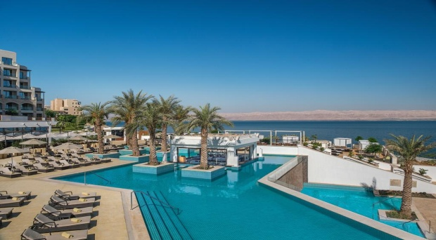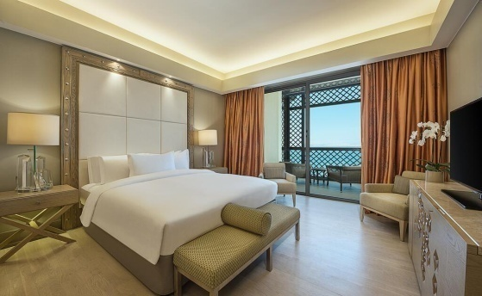

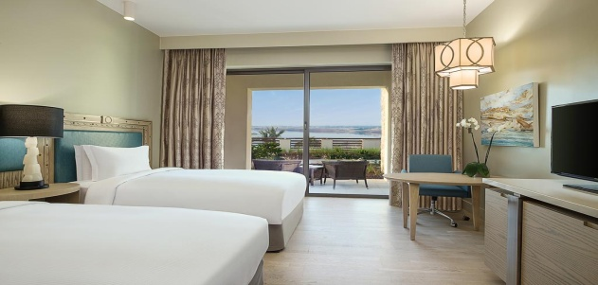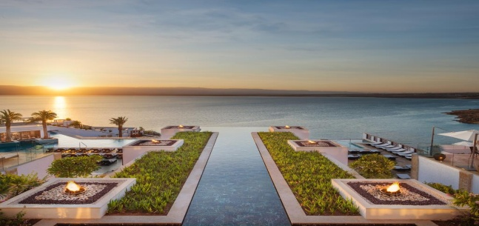

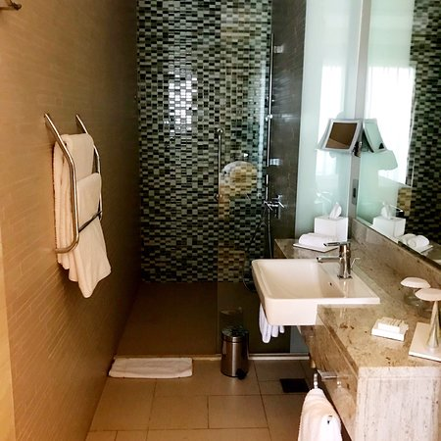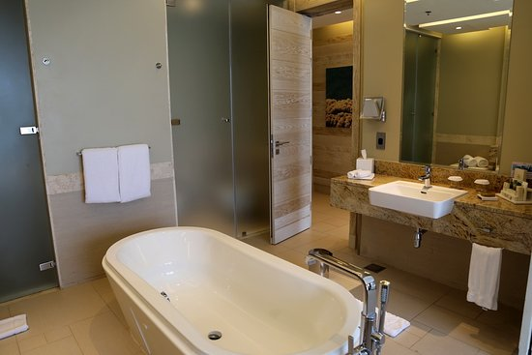

**Electricity:**

**Electrical Current in Jordan is 220V.**

**Language:**

**The official language in Jordan is Arabic while English can be used as a second language for necessity. It will be used during all the meetings.**

**Room rates :**

|  |  |
| --- | --- |
| **Single Room (€):** | **800 Euros for 3 nights’ full board**  **175 Euros per extra nights full board** |
| **Double Room (€):** | **770 Euros for 3 nights per person full board**  **150 Euros per extra nights per person full board** |

* **If you require an invoice please contact :** [**jasser.jopc@hotmail.com**](mailto:jasser.jopc@hotmail.com)

**Bank account:**

National Paralympics Committee: Jordan Paralympics Committee

|  |  |
| --- | --- |
| Jordan Sport Federation For The Handicapped | Account Name |
| Amman-Jordan - P.O.BOX (960562) | Address |
| The Housing Bank For Trade & Finance | Bank |
| Almadenah Alreyadyah | Branch |
| JO08 HBHO 0160 0000 0006 7000 2010 01 | IBAN |
| 00000 67000201001 | Account NO ($) |
| HBHOJOAXXXX | SWIFT of Beneficiary |

**Post Offices:**

**Office services available in the hotel, Delegates can send their Post Cards through it or they can ask the volunteers for assistance.**

**Communications (WIFI)**

**WIFI is available free in hotel and meetings halls, and available in all rooms.**

**Sanitary Facilities**

**Wheelchair users are provided for at the hotel.**

**Important Dates:**

|  |  |
| --- | --- |
| **1 September 2021** | **Deadline for Registration** |
| **9/10/2021** | **Participants arrival** |
| **10/10 /2021** | **meetings** |
| **11/10 /2021** | **meetings** |
| **12/10 /2021** | **Departure** |

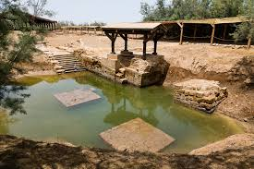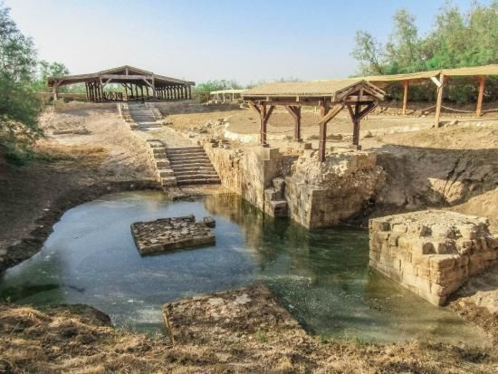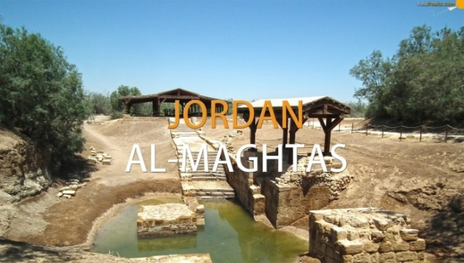

**Social Activities**

**There will be a trip arranged in the programme to visit the site where Jesus was baptized (ALMAGTAS). See above photos.**

**Please respect the deadline of 1 September for registering your participation. For those who require a visa that also would be the final date for sending the following documents:**

**1- visa request form**

**2- copy of their passports**

**3- their photographs**

**4- The proof payment of the accommodation fees**

**Contact person: Jasser nuweiran , Email :** [**jasser.jopc@hotmail.com**](mailto:jasser.jopc@hotmail.com)

**Important mobile Numbers:**

* **The Jordan Paralympic committee**

**00962656611774 / 5**

* **Ms Maha Barghouthi , Secretary General of Jordan NPC**

**Mobile: 00962795533002**

* **Mr.Jasser Nuwiran , Executive committee president**

**Mobile: 00962 795722775**

* **Mr.Daoud Shehadeh,Manager of Prince Raad Bin Zeid complex Mobile : 00962795700774**
* **Mr.Ahmad Hyasat , Tournament Coordinator**

**Mobile: 0096277765104**

* **MRS Rasha Alkhayyat**

**Mobile: 00962790918704**

**COUNTRIES WHO NEED VISAS IN ADVANCE OF ARRIVING IN JORDAN**

AddThis Sharing Buttons

##### Restricted Countries – Asia Continent

| **No.** | **Restricted Countries – Asia Continent** |
| --- | --- |
| 1 | Islamic Republic of Afghanistan |
| 2 | Islamic Republic of Iran |
| 3 | Independent State of Papua New Guinea |
| 4 | Islamic Republic of Pakistan |
| 5 | Democratic Socialist Republic of Sri Lanka |
| 6 | Republic of the Philippines |
| 7 | Socialist Republic of Vietnam |
| 8 | Kingdom of Cambodia |
| 9 | Lao People’s Democratic Republic |
| 10 | Mongolia (Republic of Mongolia) |
| 11 | Republic of the Union of Myanmar |
| 12 | Kingdom of Nepal (Federal Democratic Republic of Nepal) |
| 13 | Republic of Iraq |
| 14 | Republic of Yemen |
| 15 | Republic of bangladish |

##### Restricted Countries – Africa Continent

| **No.** | **Restricted Countries – Africa Continent** |
| --- | --- |
| 1 | Republic of Ethiopia |
| 2 | State of Eretria |
| 3 | Central African Republic |
| 4 | Republic of Angola |
| 5 | Republic of Uganda |
| 6 | Republic of Botswana |
| 7 | Republic of Benin |
| 8 | People Democratic Republic of Burkina Faso |
| 9 | Republic of Burundi |
| 10 | Republic of Chad |
| 11 | United Republic of Tanzania |
| 12 | Togolese Republic |
| 13 | Republic of Djibouti |
| 14 | Democratic Republic of the Cong (Zaire) |
| 15 | Republic of Zambia |
| 16 | Republic of Cote d’Ivoire (Ivory Coast) |
| 17 | Republic of Senegal |
| 18 | Republic of South Sudan |
| 19 | Republic of Sierra Lion |
| 20 | Federal Republic of Somalia |
| 21 | Gabonese Republic |
| 22 | Republic of the Gambia |
| 23 | Republic of Ghana |
| 24 | Republic of Guinea |
| 25 | Equator Genie Republic |
| 26 | Republic of Guinea-Bissau |
| 27 | Republic of Cameroon |
| 28 | Republic of the Congo |
| 29 | Republic of Liberia |
| 30 | Republic of Mali |
| 31 | Democratic Republic of Madagascar |
| 32 | Union of the Comoros |
| 33 | Islamic Arab Republic of Mauritania |
| 34 | Republic of Mozambique |
| 35 | Republic of Namibia |
| 36 | Republic of Niger |
| 37 | Federal Republic of Nigeria |
| 38 | Republic of The Sudan |
| 39 | Libya |

##### Restricted Countries – Europe Continent

|  |  |
| --- | --- |
| No. | Restricted Countries – Europe Continent |
| 1 | Republic of Albania |
| 2 | Republic of Moldova |

##### Restricted Countries – South America Continent

| **No.** | **Restricted Countries – South America Continent** |
| --- | --- |
| 1 | Belize |
| 2 | Republic of Cuba |
| 3 | Republic of Colombia |